Git Configurations

What is Git Configuration?
# Source: AI Source: Provided by: [Data Path: Persons Table -> ID Column: 1, Name_En Column: Motasem Essam] -> From: [ChatGPT] on [3/6/2026]
Git configuration is how you customize Git’s behavior — things like your name, email, default branch, editor, aliases, and more.
Git stores these settings in configuration files and reads them every time you use Git.

🔹 3 Levels of Git Configuration
# Source: AI Source: Provided by: [Data Path: Persons Table -> ID Column: 1, Name_En Column: Motasem Essam] -> From: [ChatGPT] on [3/6/2026]
Git has three levels, and they override each other in this order:

1️⃣ System Level (Lowest Priority)
# Source: AI Source: Provided by: [Data Path: Persons Table -> ID Column: 1, Name_En Column: Motasem Essam] -> From: [ChatGPT] on [3/6/2026]
Applies to all users on the computer.
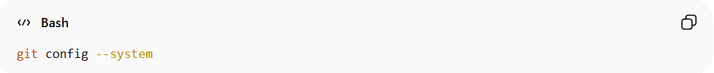
git config --system
File location:
- Windows: C:\Program Files\Git\etc\gitconfig
- Linux/macOS: /etc/gitconfig

2️⃣ Global Level (Most Common)
# Source: AI Source: Provided by: [Data Path: Persons Table -> ID Column: 1, Name_En Column: Motasem Essam] -> From: [ChatGPT] on [3/6/2026]
Applies to your user account on the machine.
git config --global
File location:
- Windows: C:\Users\YourName\.gitconfig
- Linux/macOS: ~/.gitconfig
👉 This is where you usually set your name and email.
Example:
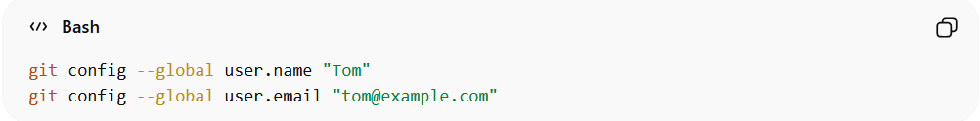
git config --global user.name "Tom"
git config --global user.email "tom@example.com"

3️⃣ Local Level (Highest Priority)
# Source: AI Source: Provided by: [Data Path: Persons Table -> ID Column: 1, Name_En Column: Motasem Essam] -> From: [ChatGPT] on [3/6/2026]
Applies to only one repository.
git config
Stored inside:
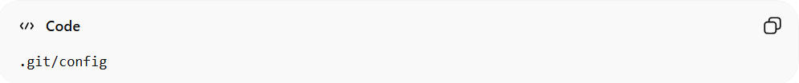
.git/config
Example:
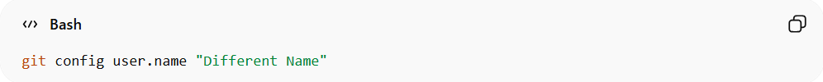
git config user.name "Different Name"
This overrides global settings for that repo only.

🔹 How to See Your Config
# Source: AI Source: Provided by: [Data Path: Persons Table -> ID Column: 1, Name_En Column: Motasem Essam] -> From: [ChatGPT] on [3/6/2026]
Show all settings:
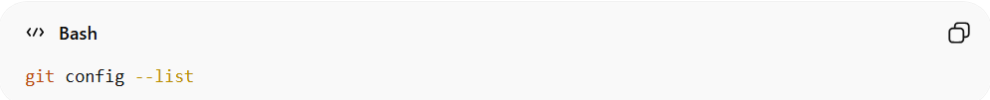
git config --list
Show only global:
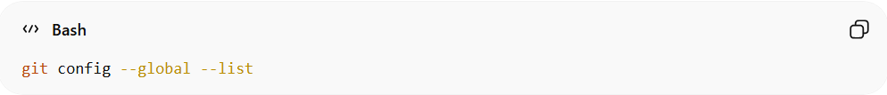
git config --global --list
Show where each setting comes from:
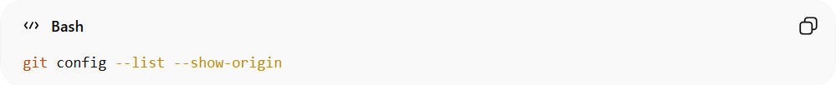
git config --list --show-origin

🔹 Common Git Configurations

setting your Git user name and email

🔹 1️⃣ Set Your Git User Name
# Source: AI Source: Provided by: [Data Path: Persons Table -> ID Column: 1, Name_En Column: Motasem Essam] -> From: [ChatGPT] on [3/6/2026]
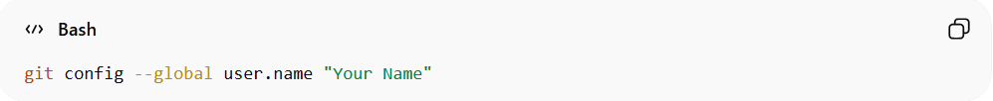
git config --global user.name "Your Name"
✅ This sets the name that appears on every commit you make globally (for all repositories on your machine).
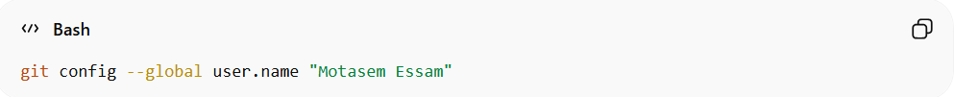
git config --global user.name "Motasem Essam"
Now every commit will show Motasem Essam as the author name.

🔹 2️⃣ Set Your Git User Email
# Source: AI Source: Provided by: [Data Path: Persons Table -> ID Column: 1, Name_En Column: Motasem Essam] -> From: [ChatGPT] on [3/6/2026]
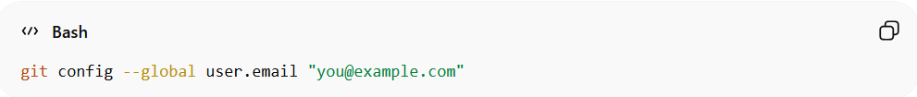
git config --global user.email "you@example.com"
✅ This sets the email address that appears on every commit globally.
Example:
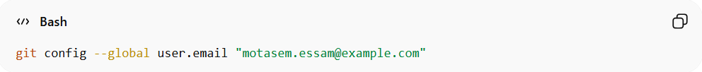
git config --global user.email "motasem.essam@example.com"
Now every commit will show this email as the author email.

🔹 3️⃣ Verify Your Name and Email
# Source: AI Source: Provided by: [Data Path: Persons Table -> ID Column: 1, Name_En Column: Motasem Essam] -> From: [ChatGPT] on [3/6/2026]
Check that Git is using the correct identity:
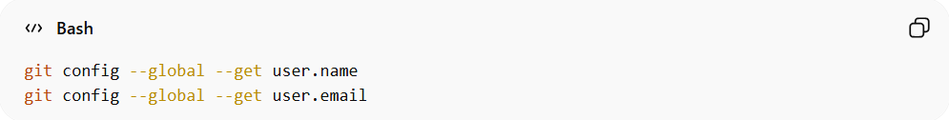
git config --global --get user.name
git config --global --get user.email
- Git will display your global user name and email.
- Ensures commits are correctly attributed to you.

🔹 4️⃣ Optional: Set Name/Email Only for One Repository
# Source: AI Source: Provided by: [Data Path: Persons Table -> ID Column: 1, Name_En Column: Motasem Essam] -> From: [ChatGPT] on [3/6/2026]
Inside a specific repository, you can override the global settings:
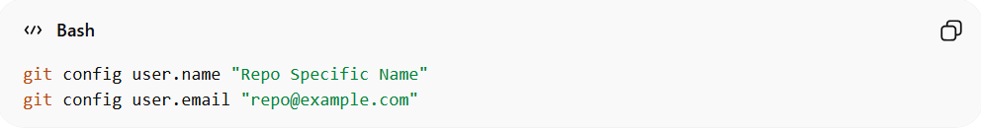
git config user.name "Repo Specific Name"
git config user.email "repo@example.com"
- These values apply only to this repository.
- Useful if you contribute to multiple projects with different identities.

✅ Summary
# Source: AI Source: Provided by: [Data Path: Persons Table -> ID Column: 1, Name_En Column: Motasem Essam] -> From: [ChatGPT] on [3/6/2026]
- user.name → your author name in commits
- user.email → your author email in commits
- --global → applies to all repositories
- Omitting --global → applies only to the current repository

Set default branch name:
# Source: AI Source: Provided by: [Data Path: Persons Table -> ID Column: 1, Name_En Column: Motasem Essam] -> From: [ChatGPT] on [3/6/2026]
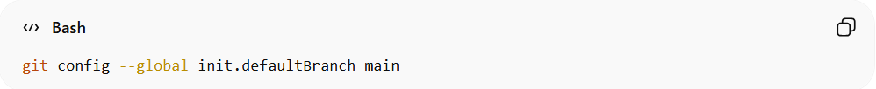
git config --global init.defaultBranch main

🔹 What This Command Does
# Source: AI Source: Provided by: [Data Path: Persons Table -> ID Column: 1, Name_En Column: Motasem Essam] -> From: [ChatGPT] on [3/6/2026]
It tells Git:
“Whenever I create a new repository using git init, use main as the default branch name.”

🔹 Why This Matters
# Source: AI Source: Provided by: [Data Path: Persons Table -> ID Column: 1, Name_En Column: Motasem Essam] -> From: [ChatGPT] on [3/6/2026]
Older versions of Git used:
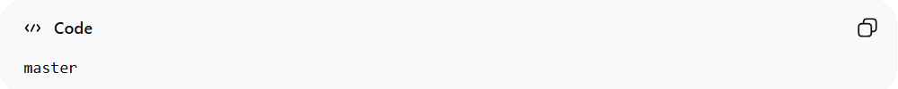
Master

as the default branch name.
Now many platforms like:
- GitHub
- GitLab
- Bitbucket
use:
main
as the standard default branch name.
Without this setting, running:
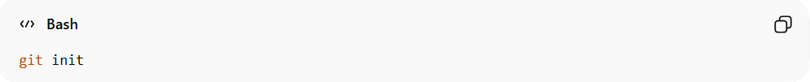
git init

might create:
master
instead of:
Main

🔹 What Each Part Means
# Source: AI Source: Provided by: [Data Path: Persons Table -> ID Column: 1, Name_En Column: Motasem Essam] -> From: [ChatGPT] on [3/6/2026]
git config
Used to set Git settings.
--global
Applies the setting to your entire system (your user account).
init.defaultBranch
The configuration key that controls the default branch name when running git init.
main
The value you’re setting.

🔹 What Happens After Setting It
# Source: AI Source: Provided by: [Data Path: Persons Table -> ID Column: 1, Name_En Column: Motasem Essam] -> From: [ChatGPT] on [3/6/2026]
Now when you run:
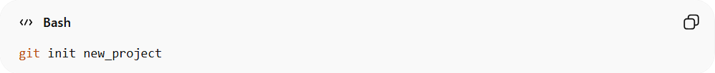
git init new_project

Git automatically creates:
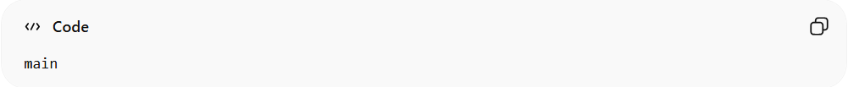
Main

instead of:
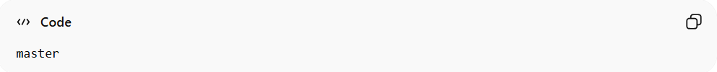
master

You can verify:
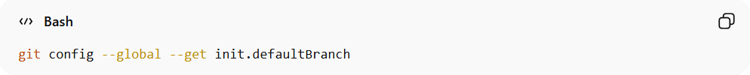
git config --global --get init.defaultBranch

Set default editor:
# Source: AI Source: Provided by: [Data Path: Persons Table -> ID Column: 1, Name_En Column: Motasem Essam] -> From: [ChatGPT] on [3/6/2026]
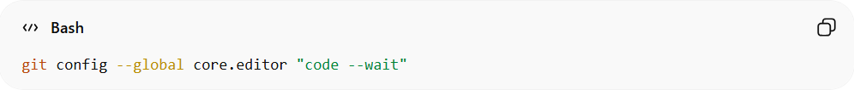
git config --global core.editor "code --wait"

🔹 What This Command Does
# Source: AI Source: Provided by: [Data Path: Persons Table -> ID Column: 1, Name_En Column: Motasem Essam] -> From: [ChatGPT] on [3/6/2026]
It tells Git:
“When you need me to write a message (like a commit message), open Visual Studio Code as the editor.”

🔹 Why Git Needs an Editor
# Source: AI Source: Provided by: [Data Path: Persons Table -> ID Column: 1, Name_En Column: Motasem Essam] -> From: [ChatGPT] on [3/6/2026]
Git opens an editor when you:
- Run git commit without -m
- Run git rebase -i
- Edit a merge commit message
- Edit tags
If you don’t configure it, Git may open:
- Vim (default on many systems)
- Nano
- Or another terminal editor
Some beginners get stuck in Vim 😅

This command:
- Sets VS Code as your default Git editor
- Prevents being stuck in Vim
- Makes writing commit messages easier
Applies to all your repositories

🔹 What Each Part Means
# Source: AI Source: Provided by: [Data Path: Persons Table -> ID Column: 1, Name_En Column: Motasem Essam] -> From: [ChatGPT] on [3/6/2026]
git config
Sets a Git setting.
--global
Applies to your entire user account (all repositories).
core.editor
The setting that defines the default editor Git should use.
"code --wait"
- code → launches Visual Studio Code
- --wait → tells Git to pause until you close the file
⚠️ The --wait part is very important.
Without it, Git will continue immediately and may create an empty commit message.

🔹 What Happens After Setting It
# Source: AI Source: Provided by: [Data Path: Persons Table -> ID Column: 1, Name_En Column: Motasem Essam] -> From: [ChatGPT] on [3/6/2026]
Now when you run:
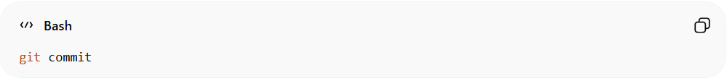
git commit

Instead of typing:
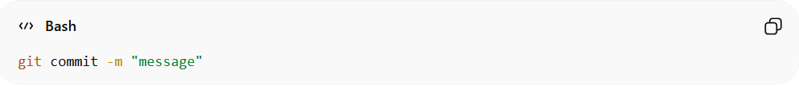
git commit -m "message"

VS Code opens with a file like:
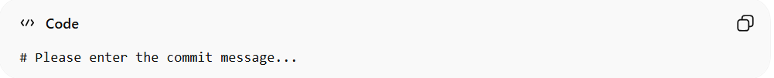
# Please enter the commit message...

You write your message, save, close VS Code —
Git continues and completes the commit.

🔹 If code Doesn’t Work
# Source: AI Source: Provided by: [Data Path: Persons Table -> ID Column: 1, Name_En Column: Motasem Essam] -> From: [ChatGPT] on [3/6/2026]
It means VS Code isn’t added to your PATH.
In VS Code:
- Press Ctrl + Shift + P
- Type: Shell Command
- Select: Install 'code' command in PATH
- Restart terminal

🔹 Other Editor Examples
# Source: AI Source: Provided by: [Data Path: Persons Table -> ID Column: 1, Name_En Column: Motasem Essam] -> From: [ChatGPT] on [3/6/2026]
Use Notepad (Windows):
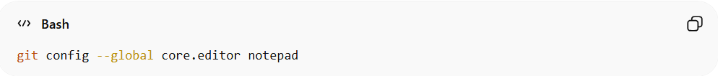
git config --global core.editor notepad
Use Nano:
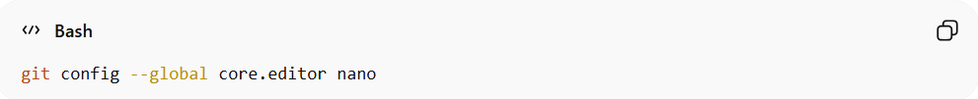
git config --global core.editor nano
Use Vim:
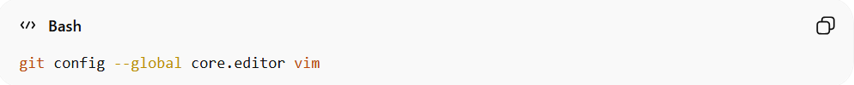
git config --global core.editor vim

🔹 Set Notepad++ as the Default Git Editor
# Source: AI Source: Provided by: [Data Path: Persons Table -> ID Column: 1, Name_En Column: Motasem Essam] -> From: [ChatGPT] on [3/6/2026]
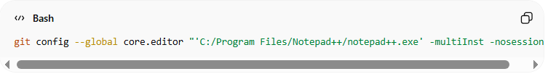
git config --global core.editor "'C:/Program Files/Notepad++/notepad++.exe' -multiInst -nosession"

✅ Explanation
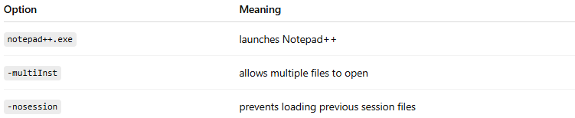
Option | Meaning
notepad++.exe | launches Notepad++
-multiInst | allows multiple files to open
-nosession | prevents loading previous session files

🔹 Check Your Current Editor
# Source: AI Source: Provided by: [Data Path: Persons Table -> ID Column: 1, Name_En Column: Motasem Essam] -> From: [ChatGPT] on [3/6/2026]
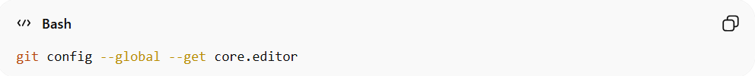
git config --global --get core.editor

Enable colored output:
# Source: AI Source: Provided by: [Data Path: Persons Table -> ID Column: 1, Name_En Column: Motasem Essam] -> From: [ChatGPT] on [3/6/2026]
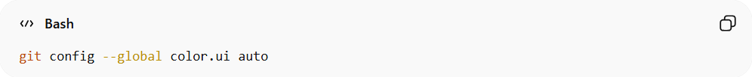
git config --global color.ui auto

🔹 What This Command Does
# Source: AI Source: Provided by: [Data Path: Persons Table -> ID Column: 1, Name_En Column: Motasem Essam] -> From: [ChatGPT] on [3/6/2026]
It tells Git:
“Automatically use colors in the terminal output when it makes sense.”
So commands like git status, git diff, and git log will show colored output.

🔹 Why This Is Useful
# Source: AI Source: Provided by: [Data Path: Persons Table -> ID Column: 1, Name_En Column: Motasem Essam] -> From: [ChatGPT] on [3/6/2026]
Without colors, Git output looks plain and harder to read:
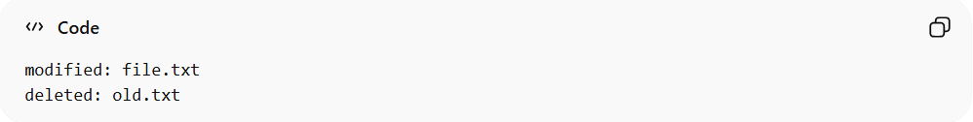
modified: file.txt
deleted: old.txt
With colors enabled:
- 🟢 Green → new files
- 🔴 Red → deleted files
- 🟡 Yellow → modified files
- 🔵 Blue → branch names
- 🔷 Colored diffs for added/removed lines
It makes changes much easier to see quickly.

This command:
- Makes Git output easier to read
- Highlights changes visually
- Applies to all your repositories
Uses smart automatic coloring

🔹 What Each Part Means
# Source: AI Source: Provided by: [Data Path: Persons Table -> ID Column: 1, Name_En Column: Motasem Essam] -> From: [ChatGPT] on [3/6/2026]
git config
Sets a Git setting.
--global
Applies the setting to your user account (all repositories).
color.ui
The configuration key controlling color behavior.
auto
Means:
- Use colors when output is shown in a terminal.
- Do NOT use colors when output is redirected to a file.

🔹 The 3 Possible Values
# Source: AI Source: Provided by: [Data Path: Persons Table -> ID Column: 1, Name_En Column: Motasem Essam] -> From: [ChatGPT] on [3/6/2026]
1️⃣ auto (Recommended)
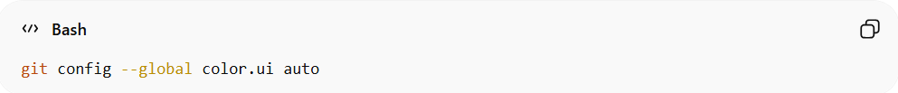
git config --global color.ui auto
Colors appear in terminal only.
2️⃣ always
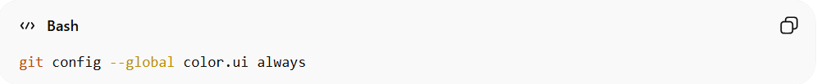
git config --global color.ui always
Forces color even when output is redirected.
(Not usually recommended.)
3️⃣ never
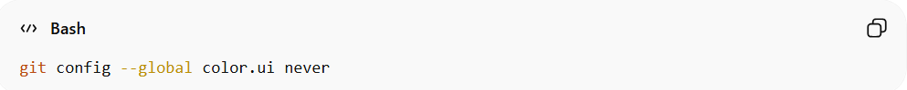
git config --global color.ui never
Disables all color output.

🔹 Example Difference
Run:
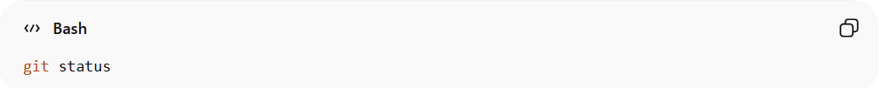
git status
With color enabled:
- Modified files appear yellow
- Untracked files appear red
- Branch name appears green
Without color:
Everything appears plain white text.

🔹 Check Current Setting
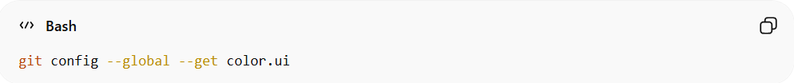
git config --global --get color.ui

Create alias (shortcut):
# Source: AI Source: Provided by: [Data Path: Persons Table -> ID Column: 1, Name_En Column: Motasem Essam] -> From: [ChatGPT] on [3/6/2026]
git config --global alias.st status
Now you can use:
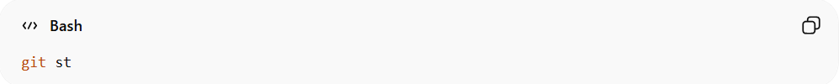
git st

🔹 What This Does
# Source: AI Source: Provided by: [Data Path: Persons Table -> ID Column: 1, Name_En Column: Motasem Essam] -> From: [ChatGPT] on [3/6/2026]
It creates a Git alias named st.
That alias runs the command:
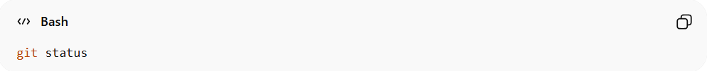
git status
So after setting it, instead of typing:
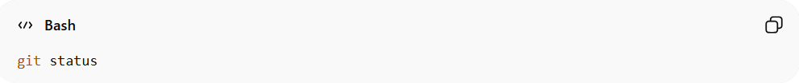
git status
You can type:
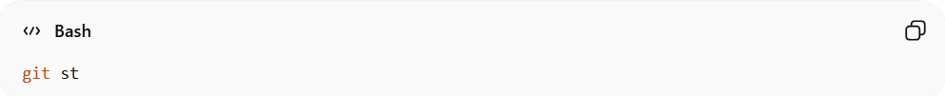
git st
Same result. Less typing.

🔹 Breaking It Down
# Source: AI Source: Provided by: [Data Path: Persons Table -> ID Column: 1, Name_En Column: Motasem Essam] -> From: [ChatGPT] on [3/6/2026]
git config
Used to set Git configuration values.
--global
Applies the alias to your entire user account (all repositories).
alias.st
- alias → tells Git you’re creating a shortcut.
- st → the shortcut name you’re creating.
status
The actual Git command that runs when you type git st.

🔹 What Happens Internally
# Source: AI Source: Provided by: [Data Path: Persons Table -> ID Column: 1, Name_En Column: Motasem Essam] -> From: [ChatGPT] on [3/6/2026]
Git saves this in your global config file:
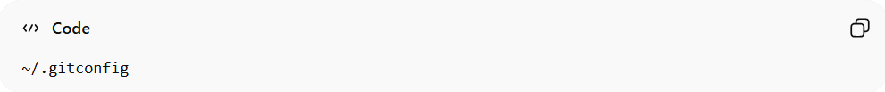
~/.gitconfig
It will look like this:
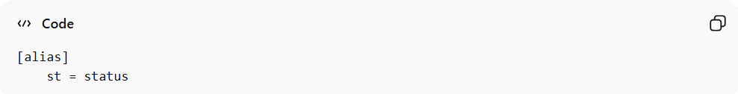
[alias]
st = status

🔹 After Setting It
Now this:
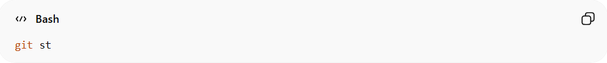
git st
Is exactly the same as:
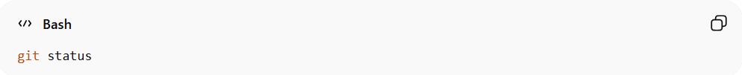
git status

🔹 Why Use Aliases?
# Source: AI Source: Provided by: [Data Path: Persons Table -> ID Column: 1, Name_En Column: Motasem Essam] -> From: [ChatGPT] on [3/6/2026]
- Saves time
- Reduces typing
- Makes your workflow faster
- Can simplify long commands

🔹 Check Your Aliases
# Source: AI Source: Provided by: [Data Path: Persons Table -> ID Column: 1, Name_En Column: Motasem Essam] -> From: [ChatGPT] on [3/6/2026]
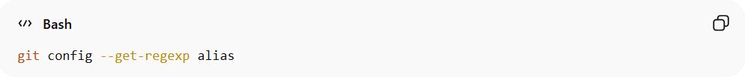
git config --get-regexp alias

🔹 Remove the Alias
# Source: AI Source: Provided by: [Data Path: Persons Table -> ID Column: 1, Name_En Column: Motasem Essam] -> From: [ChatGPT] on [3/6/2026]
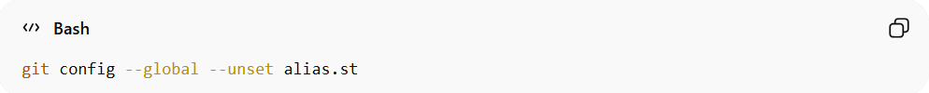
git config --global --unset alias.st

🚀 Pro Tip
# Source: AI Source: Provided by: [Data Path: Persons Table -> ID Column: 1, Name_En Column: Motasem Essam] -> From: [ChatGPT] on [3/6/2026]
Many developers create these common aliases:
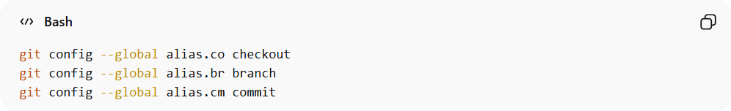
git config --global alias.co checkout
git config --global alias.br branch
git config --global alias.cm commit
Then they can run:
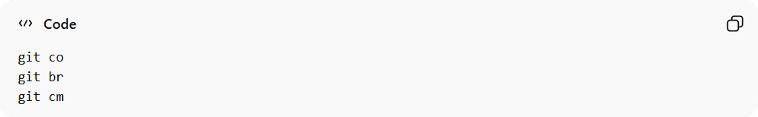
git co
git br
git cm
Much faster workflow.

Set Your Default Push Behavior (Recommended First)
# Source: AI Source: Provided by: [Data Path: Persons Table -> ID Column: 1, Name_En Column: Motasem Essam] -> From: [ChatGPT] on [3/6/2026]
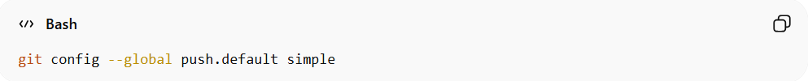
git config --global push.default simple

🔹 What is push.default?
# Source: AI Source: Provided by: [Data Path: Persons Table -> ID Column: 1, Name_En Column: Motasem Essam] -> From: [ChatGPT] on [3/6/2026]
It controls what happens when you run:
git push
Without specifying branch name.

🔹 What does simple mean?
# Source: AI Source: Provided by: [Data Path: Persons Table -> ID Column: 1, Name_En Column: Motasem Essam] -> From: [ChatGPT] on [3/6/2026]
When set to simple:
👉 Git will push:
- The current branch
- To the branch with the same name
- On the remote repository

🔥 Example
# Source: AI Source: Provided by: [Data Path: Persons Table -> ID Column: 1, Name_En Column: Motasem Essam] -> From: [ChatGPT] on [3/6/2026]
You are on branch:
main
You run:
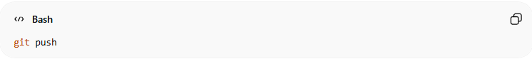
git push
With push.default simple:
✅ Git pushes:
local main → origin/main
❌ If the branch names are different, Git will stop and show an error (for safety).

🔹 Why is it Recommended?
# Source: AI Source: Provided by: [Data Path: Persons Table -> ID Column: 1, Name_En Column: Motasem Essam] -> From: [ChatGPT] on [3/6/2026]
Because it is:
- ✅ Safe
- ✅ Prevents accidental pushes
- ✅ Avoids pushing to wrong branch
- ✅ Default behavior in modern Git versions

🔥 What Happens If Branch Names Differ?
# Source: AI Source: Provided by: [Data Path: Persons Table -> ID Column: 1, Name_En Column: Motasem Essam] -> From: [ChatGPT] on [3/6/2026]
If you are on:
feature-login
But remote branch is:
login-feature
git push will FAIL.
It forces you to explicitly run:
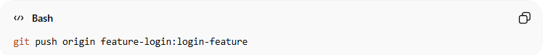
git push origin feature-login:login-feature
So you don’t accidentally overwrite something.

🔹 Why Use --global?
# Source: AI Source: Provided by: [Data Path: Persons Table -> ID Column: 1, Name_En Column: Motasem Essam] -> From: [ChatGPT] on [3/6/2026]
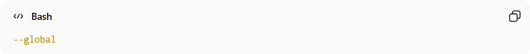
--global
Means:
- Apply this setting to all repositories on your computer.
Stored in:
~/.gitconfig

🔥 Other Possible Values (Just For Knowledge)
# Source: AI Source: Provided by: [Data Path: Persons Table -> ID Column: 1, Name_En Column: Motasem Essam] -> From: [ChatGPT] on [3/6/2026]
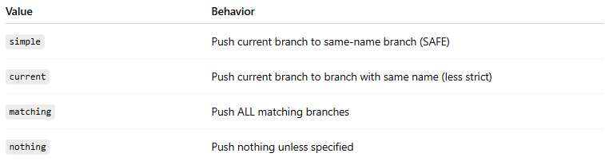
Value | Behavior
simple | Push current branch to same-name branch (SAFE)
current | Push current branch to branch with same name (less strict)
matching | Push ALL matching branches
nothing | Push nothing unless specified

🧠 Simple Definition
# Source: AI Source: Provided by: [Data Path: Persons Table -> ID Column: 1, Name_En Column: Motasem Essam] -> From: [ChatGPT] on [3/6/2026]
push.default simple
“Push my current branch only to a branch with the same name, and stop if something looks wrong.”

Automatically Set Upstream on First Push
# Source: AI Source: Provided by: [Data Path: Persons Table -> ID Column: 1, Name_En Column: Motasem Essam] -> From: [ChatGPT] on [3/6/2026]
git config --global push.autoSetupRemote true

🔹 First: What is "Upstream"?
# Source: AI Source: Provided by: [Data Path: Persons Table -> ID Column: 1, Name_En Column: Motasem Essam] -> From: [ChatGPT] on [3/6/2026]
When you connect a local branch to a remote branch, Git remembers the relationship.
Example:
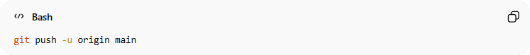
git push -u origin main
The -u means:
👉 Set origin/main as the upstream of your local main branch.
After that, you can just run:
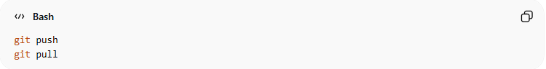
git push
git pull
Without writing origin main every time.

🔥 What Does push.autoSetupRemote true Do?
# Source: AI Source: Provided by: [Data Path: Persons Table -> ID Column: 1, Name_En Column: Motasem Essam] -> From: [ChatGPT] on [3/6/2026]
It tells Git:
“When I push a new branch for the first time, automatically set the upstream branch.”
So instead of doing this:
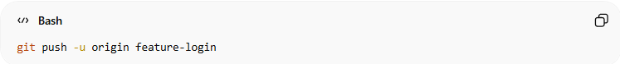
git push -u origin feature-login
You can just do:
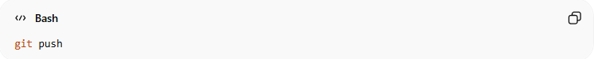
git push
And Git will:
- Push the branch
- Automatically set upstream
- Remember the tracking branch

🔹 Example Scenario
# Source: AI Source: Provided by: [Data Path: Persons Table -> ID Column: 1, Name_En Column: Motasem Essam] -> From: [ChatGPT] on [3/6/2026]
1️⃣ Create new branch
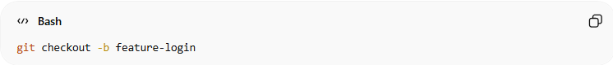
git checkout -b feature-login
2️⃣ Push normally
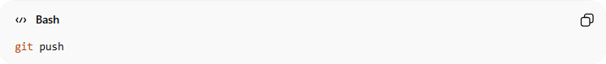
git push
Without this setting ❌
Git would say:
fatal: The current branch has no upstream branch.
With this setting ✅
Git will:
- Create origin/feature-login
- Link it automatically

🔹 Why Use --global?
# Source: AI Source: Provided by: [Data Path: Persons Table -> ID Column: 1, Name_En Column: Motasem Essam] -> From: [ChatGPT] on [3/6/2026]
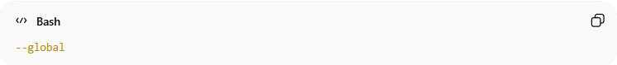
--global
Means:
- Apply to all repositories on your computer.
- Saved inside:
~/.gitconfig

🔥 Why Is This Useful?
# Source: AI Source: Provided by: [Data Path: Persons Table -> ID Column: 1, Name_En Column: Motasem Essam] -> From: [ChatGPT] on [3/6/2026]
It saves you from writing:
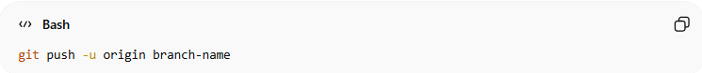
git push -u origin branch-name
Every time you create a new branch.

🧠 Simple Definition
# Source: AI Source: Provided by: [Data Path: Persons Table -> ID Column: 1, Name_En Column: Motasem Essam] -> From: [ChatGPT] on [3/6/2026]
push.autoSetupRemote true
“Automatically connect my local branch to the remote branch on first push.”

🔥 Relationship with push.default simple
# Source: AI Source: Provided by: [Data Path: Persons Table -> ID Column: 1, Name_En Column: Motasem Essam] -> From: [ChatGPT] on [3/6/2026]
They work very well together:
- push.default simple → controls HOW push behaves
- push.autoSetupRemote true → auto-connects branch on first push

Enable Rebase Instead of Merge on Pull
# Source: AI Source: Provided by: [Data Path: Persons Table -> ID Column: 1, Name_En Column: Motasem Essam] -> From: [ChatGPT] on [3/6/2026]
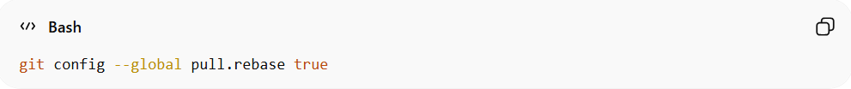
git config --global pull.rebase true

🔹 First: What happens normally with git pull?
# Source: AI Source: Provided by: [Data Path: Persons Table -> ID Column: 1, Name_En Column: Motasem Essam] -> From: [ChatGPT] on [3/6/2026]
When you run:
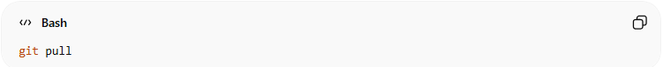
git pull
Git does:
- git fetch
- git merge
So by default:
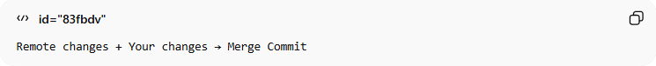
Remote changes + Your changes → Merge Commit
This creates an extra merge commit.

🔥 What Does pull.rebase true Do?
# Source: AI Source: Provided by: [Data Path: Persons Table -> ID Column: 1, Name_En Column: Motasem Essam] -> From: [ChatGPT] on [3/6/2026]
It changes the behavior of git pull.
Instead of:
fetch + merge
It does:
fetch + rebase

🔹 What is Rebase?
# Source: AI Source: Provided by: [Data Path: Persons Table -> ID Column: 1, Name_En Column: Motasem Essam] -> From: [ChatGPT] on [3/6/2026]
Rebase means:
“Move my local commits on top of the latest remote commits.”
Instead of creating a merge commit, Git rewrites your local commits to sit after the remote ones.

🔥 Visual Comparison
# Source: AI Source: Provided by: [Data Path: Persons Table -> ID Column: 1, Name_En Column: Motasem Essam] -> From: [ChatGPT] on [3/6/2026]
❌ Default (Merge)
Before pull:
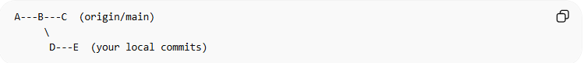
A---B---C (origin/main)
\
D---E (your local commits)
After git pull (merge):
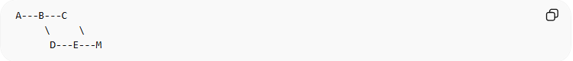
A---B---C
\ \
D---E---M
M = Merge commit (extra commit)

✅ With Rebase
# Source: AI Source: Provided by: [Data Path: Persons Table -> ID Column: 1, Name_En Column: Motasem Essam] -> From: [ChatGPT] on [3/6/2026]
After git pull:
A---B---C---D'---E'
No merge commit.
History stays clean and linear.

🔹 Why Developers Prefer Rebase?
# Source: AI Source: Provided by: [Data Path: Persons Table -> ID Column: 1, Name_En Column: Motasem Essam] -> From: [ChatGPT] on [3/6/2026]
- ✅ Cleaner commit history
- ✅ No unnecessary merge commits
- ✅ Easier to read in Git log
- ✅ Professional workflow (common in teams)

🔹 Why Use --global?
# Source: AI Source: Provided by: [Data Path: Persons Table -> ID Column: 1, Name_En Column: Motasem Essam] -> From: [ChatGPT] on [3/6/2026]
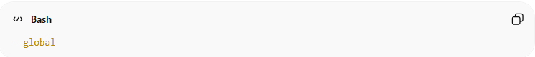
--global
Means:
- Apply this rule to all repositories.
- Saved inside:
~/.gitconfig

⚠️ Important Warning
# Source: AI Source: Provided by: [Data Path: Persons Table -> ID Column: 1, Name_En Column: Motasem Essam] -> From: [ChatGPT] on [3/6/2026]
Rebase:
- Rewrites commit history
- Should NOT be used on commits already pushed and shared (unless you understand force push)
But for normal git pull, it’s safe and recommended.

🧠 Simple Definition
# Source: AI Source: Provided by: [Data Path: Persons Table -> ID Column: 1, Name_En Column: Motasem Essam] -> From: [ChatGPT] on [3/6/2026]
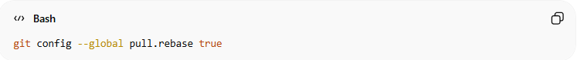
git config --global pull.rebase true
Means:
“When I run git pull, rebase my commits instead of creating a merge commit.”

Show Branch Name in Prompt (Helpful)
# Source: AI Source: Provided by: [Data Path: Persons Table -> ID Column: 1, Name_En Column: Motasem Essam] -> From: [ChatGPT] on [3/6/2026]
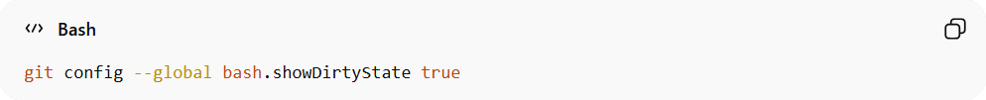
git config --global bash.showDirtyState true

🔹 What This Setting Does
# Source: AI Source: Provided by: [Data Path: Persons Table -> ID Column: 1, Name_En Column: Motasem Essam] -> From: [ChatGPT] on [3/6/2026]
When enabled:
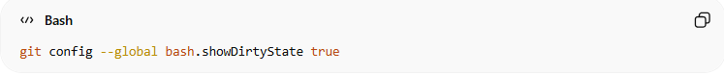
git config --global bash.showDirtyState true
It tells Git’s Bash prompt:
“Show if my repository has changes.”
This usually works together with Git’s prompt helper script (git-prompt.sh).

🔹 What You See in Terminal
Without it:
user@PC MINGW64 ~/project (main)
$
With dirty state enabled and modified files:
user@PC MINGW64 ~/project (main *)
$
The * means:
👉 You have modified files (working directory not clean).

🔥 What Does “Dirty State” Mean?
A repository is dirty when:
- You modified files
- You staged files
- You have untracked files (sometimes shown depending on config)
Clean repo:
(main)
Dirty repo:
(main *)

🔹 Where Does This Work?
This setting works if:
- You are using Git Bash (Windows)
- And your .bashrc or profile loads Git’s prompt script
Example script:
/etc/profile.d/git-prompt.sh

🔹 Important
This setting:
- ❌ Does NOT change Git behavior
- ❌ Does NOT affect commits
- ✅ Only affects how your terminal prompt looks
It is purely visual.

🧠 Simple Definition
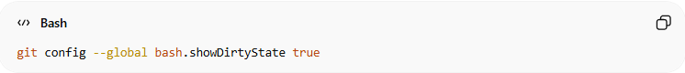
git config --global bash.showDirtyState true
Means:
“Show a symbol in my terminal when my repository has uncommitted changes.”

🔥 Bonus: Related Useful Prompt Settings
Show untracked files:
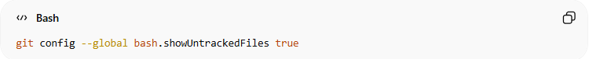
git config --global bash.showUntrackedFiles true
Show upstream status:
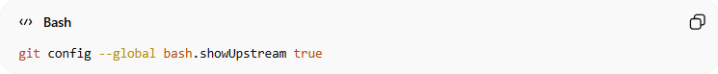
git config --global bash.showUpstream true

Enable Automatic Pruning of Deleted Remote Branches
# Source: AI Source: Provided by: [Data Path: Persons Table -> ID Column: 1, Name_En Column: Motasem Essam] -> From: [ChatGPT] on [3/6/2026]
git config --global fetch.prune true

🔹 What Is Pruning?
# Source: AI Source: Provided by: [Data Path: Persons Table -> ID Column: 1, Name_En Column: Motasem Essam] -> From: [ChatGPT] on [3/6/2026]
When a remote branch is deleted (for example on GitHub):
origin/feature-login
If your local repository still has a reference like:
remotes/origin/feature-login
Git considers it stale.
Pruning = removing these stale references automatically when fetching.

🔹 What Happens Normally Without This Setting
# Source: AI Source: Provided by: [Data Path: Persons Table -> ID Column: 1, Name_En Column: Motasem Essam] -> From: [ChatGPT] on [3/6/2026]
- Remote branch deleted:
origin/feature-login removed on GitHub
- Local fetch:
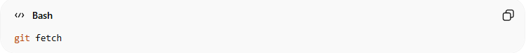
git fetch
- Old remote reference still exists:
git branch -r
Shows:
origin/feature-login
You have to manually remove it:
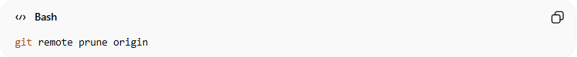
git remote prune origin

🔹 What fetch.prune true Does
# Source: AI Source: Provided by: [Data Path: Persons Table -> ID Column: 1, Name_En Column: Motasem Essam] -> From: [ChatGPT] on [3/6/2026]
When enabled:
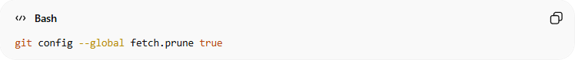
git config --global fetch.prune true
- Every time you run:
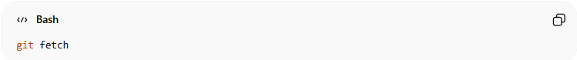
git fetch
Git will automatically:
- Check remote
- Delete any stale remote-tracking branches
- Keep your local references clean ✅

🔹 Example Workflow
# Source: AI Source: Provided by: [Data Path: Persons Table -> ID Column: 1, Name_En Column: Motasem Essam] -> From: [ChatGPT] on [3/6/2026]
- Remote branch deleted:
origin/bugfix
- Run fetch:
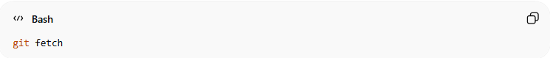
git fetch
- Output:
* [pruned] origin/bugfix
- Branch is removed from your local remote-tracking list automatically.

🔹 Why Use --global?
# Source: AI Source: Provided by: [Data Path: Persons Table -> ID Column: 1, Name_En Column: Motasem Essam] -> From: [ChatGPT] on [3/6/2026]
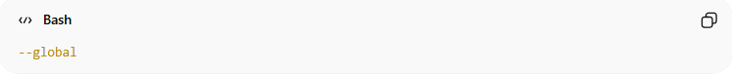
--global
- Makes this behavior default for all repos on your computer
- Saved in:
~/.gitconfig

🔹 Benefits
# Source: AI Source: Provided by: [Data Path: Persons Table -> ID Column: 1, Name_En Column: Motasem Essam] -> From: [ChatGPT] on [3/6/2026]
- ✅ Keeps your local repository tidy
- ✅ Avoid confusion from deleted branches
- ✅ Avoids manual git remote prune origin every time

🧠 Simple Definition
# Source: AI Source: Provided by: [Data Path: Persons Table -> ID Column: 1, Name_En Column: Motasem Essam] -> From: [ChatGPT] on [3/6/2026]
fetch.prune true =
“Whenever I fetch from remote, automatically remove references to branches that no longer exist remotely.”

Improve Diff Readability
# Source: AI Source: Provided by: [Data Path: Persons Table -> ID Column: 1, Name_En Column: Motasem Essam] -> From: [ChatGPT] on [3/6/2026]
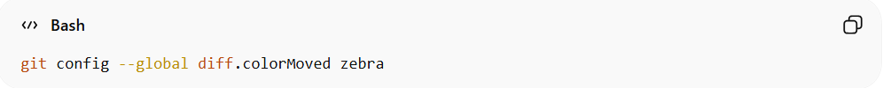
git config --global diff.colorMoved zebra

🔹 What Is a Diff in Git?
# Source: AI Source: Provided by: [Data Path: Persons Table -> ID Column: 1, Name_En Column: Motasem Essam] -> From: [ChatGPT] on [3/6/2026]
- A diff shows the differences between files:
  - What changed in your working directory vs. last commit
  - What changed between commits
Example:
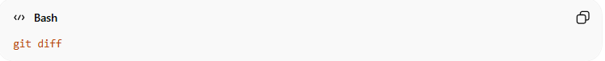
git diff

🔹 Problem Without colorMoved
# Source: AI Source: Provided by: [Data Path: Persons Table -> ID Column: 1, Name_En Column: Motasem Essam] -> From: [ChatGPT] on [3/6/2026]
If you move lines of code (cut and paste), Git normally shows it as:
- Lines deleted
- Lines added
This can be confusing, especially in large files.

🔹 What diff.colorMoved Does
# Source: AI Source: Provided by: [Data Path: Persons Table -> ID Column: 1, Name_En Column: Motasem Essam] -> From: [ChatGPT] on [3/6/2026]
- Highlights lines that were moved instead of just added/deleted
- Makes diffs easier to read
- zebra = a coloring style that alternates colors for moved blocks

🔹 Example
# Source: AI Source: Provided by: [Data Path: Persons Table -> ID Column: 1, Name_En Column: Motasem Essam] -> From: [ChatGPT] on [3/6/2026]
Suppose you have:
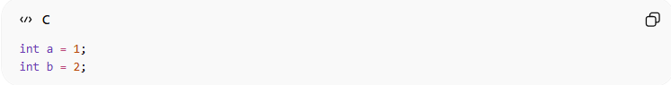
int a = 1;
int b = 2;
And you move int b = 2; above int a = 1;.
Without colorMoved:
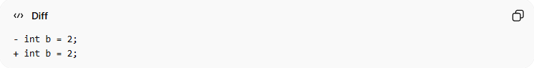
- int b = 2;
+ int b = 2;
With diff.colorMoved zebra:
- Git highlights this line was moved
- You can see it’s not a new line, just relocated

🔹 Other Options
# Source: AI Source: Provided by: [Data Path: Persons Table -> ID Column: 1, Name_En Column: Motasem Essam] -> From: [ChatGPT] on [3/6/2026]
diff.colorMoved can be set to:
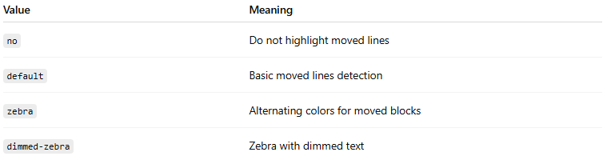
Value | Meaning
no | Do not highlight moved lines
default | Basic moved lines detection
zebra | Alternating colors for moved blocks
dimmed-zebra | Zebra with dimmed text

🔹 Why Use --global?
# Source: AI Source: Provided by: [Data Path: Persons Table -> ID Column: 1, Name_En Column: Motasem Essam] -> From: [ChatGPT] on [3/6/2026]
--global
- Applies to all repositories on your computer
- Stored in:
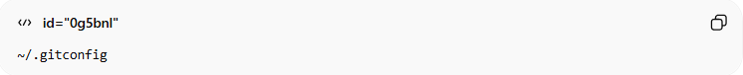
~/.gitconfig

🔹 Summary
# Source: AI Source: Provided by: [Data Path: Persons Table -> ID Column: 1, Name_En Column: Motasem Essam] -> From: [ChatGPT] on [3/6/2026]
- diff.colorMoved zebra → highlights lines that were moved
- Improves diff readability for large or reorganized files
- Helps spot real changes vs. relocated lines

Enable Credential Storage (So You Don’t Enter Password Every Time)
# Source: AI Source: Provided by: [Data Path: Persons Table -> ID Column: 1, Name_En Column: Motasem Essam] -> From: [ChatGPT] on [3/6/2026]
Git normally asks for your username/password every time you interact with a remote (like GitHub). Credential storage lets Git remember your credentials so you don’t have to type them every time.

🔹 Command Examples

1️⃣ For Windows (Recommended)
# Source: AI Source: Provided by: [Data Path: Persons Table -> ID Column: 1, Name_En Column: Motasem Essam] -> From: [ChatGPT] on [3/6/2026]
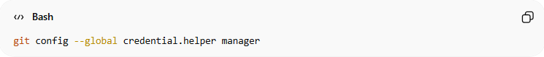
git config --global credential.helper manager
- Uses Git Credential Manager (GCM)
- Securely stores credentials in Windows Credential Manager
- Supports HTTPS remotes
- Automatically prompts for 2FA or tokens when needed

2️⃣ Cross-platform Simple Store
# Source: AI Source: Provided by: [Data Path: Persons Table -> ID Column: 1, Name_En Column: Motasem Essam] -> From: [ChatGPT] on [3/6/2026]
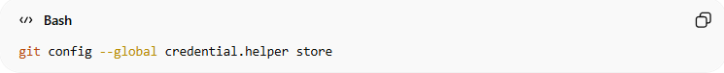
git config --global credential.helper store
- Stores credentials in plaintext in your ~/.git-credentials file
- Simpler but less secure than manager

🔹 How It Works
# Source: AI Source: Provided by: [Data Path: Persons Table -> ID Column: 1, Name_En Column: Motasem Essam] -> From: [ChatGPT] on [3/6/2026]
- First time you push/pull:
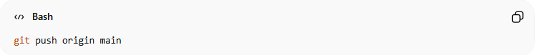
git push origin main
Git asks for username/password (or token).
- Git saves it (depending on helper):
- manager → Windows Credential Manager (encrypted)
- store → ~/.git-credentials (plain text)
- Next time you push/pull → no password required

🔹 Example Flow (Windows, manager)
# Source: AI Source: Provided by: [Data Path: Persons Table -> ID Column: 1, Name_En Column: Motasem Essam] -> From: [ChatGPT] on [3/6/2026]
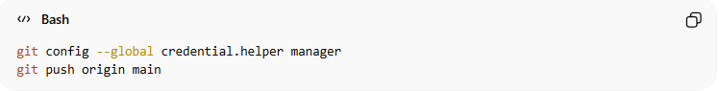
git config --global credential.helper manager
git push origin main
- Prompt appears: Enter GitHub username + personal access token
- Next push → automatic, no prompt

🔹 Security Notes
# Source: AI Source: Provided by: [Data Path: Persons Table -> ID Column: 1, Name_En Column: Motasem Essam] -> From: [ChatGPT] on [3/6/2026]
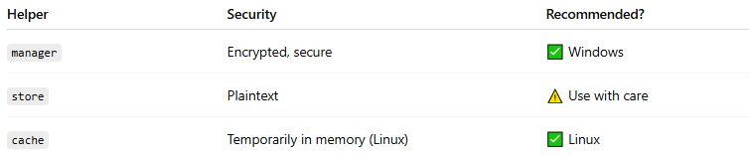
Helper | Security | Recommended?
manager | Encrypted, secure | ✅ Windows
store | Plaintext | ⚠️ Use with care
cache | Temporarily in memory (Linux) | ✅ Linux

🔹 Why Use --global?
# Source: AI Source: Provided by: [Data Path: Persons Table -> ID Column: 1, Name_En Column: Motasem Essam] -> From: [ChatGPT] on [3/6/2026]
--global
- Applies to all Git repositories on your computer
- Stored in ~/.gitconfig

🧠 Simple Definition
# Source: AI Source: Provided by: [Data Path: Persons Table -> ID Column: 1, Name_En Column: Motasem Essam] -> From: [ChatGPT] on [3/6/2026]
credential.helper manager or store
= “Remember my credentials so I don’t type my password every time I push/pull.”

Show Better Log Format
# Source: AI Source: Provided by: [Data Path: Persons Table -> ID Column: 1, Name_En Column: Motasem Essam] -> From: [ChatGPT] on [3/6/2026]
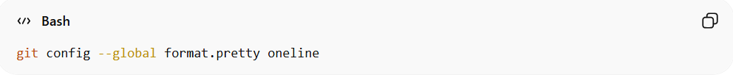
git config --global format.pretty oneline

🔹 What Is format.pretty?
# Source: AI Source: Provided by: [Data Path: Persons Table -> ID Column: 1, Name_En Column: Motasem Essam] -> From: [ChatGPT] on [3/6/2026]
It controls how git log displays commits by default.
Normally when you run:
git log
You see something like:
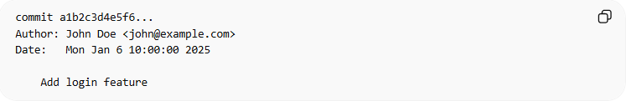
commit a1b2c3d4e5f6...
Author: John Doe <john@example.com>
Date: Tue Mar 3 10:00:00 2026

Add login feature
This is the full detailed format.

🔹 What Does oneline Do?
# Source: AI Source: Provided by: [Data Path: Persons Table -> ID Column: 1, Name_En Column: Motasem Essam] -> From: [ChatGPT] on [3/6/2026]
If you set:
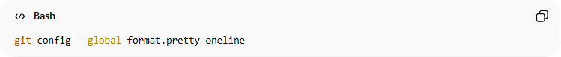
git config --global format.pretty oneline
Now when you run:
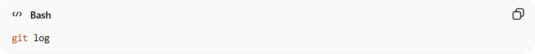
git log
You’ll see:
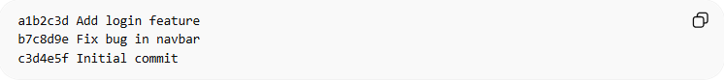
a1b2c3d Add login feature
b7c8d9e Fix bug in navbar
c3d4e5f Initial commit
👉 One commit per line
👉 Short hash + commit message only
Much cleaner and compact ✅

🔹 Why Use It?
# Source: AI Source: Provided by: [Data Path: Persons Table -> ID Column: 1, Name_En Column: Motasem Essam] -> From: [ChatGPT] on [3/6/2026]
- ✅ Faster to scan commit history
- ✅ Cleaner output
- ✅ Useful for small terminal windows
- ✅ Great for beginners

🔹 What --global Means
# Source: AI Source: Provided by: [Data Path: Persons Table -> ID Column: 1, Name_En Column: Motasem Essam] -> From: [ChatGPT] on [3/6/2026]
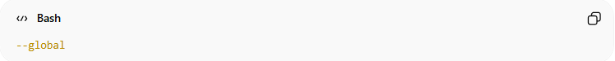
--global
- Applies to all repositories
- Saved in:
~/.gitconfig

🔥 Alternative (Without Changing Global Setting)
# Source: AI Source: Provided by: [Data Path: Persons Table -> ID Column: 1, Name_En Column: Motasem Essam] -> From: [ChatGPT] on [3/6/2026]
You can always run:
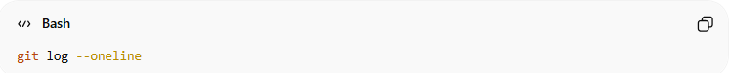
git log --oneline
This gives the same result temporarily without changing configuration.

🔹 Other Pretty Formats
# Source: AI Source: Provided by: [Data Path: Persons Table -> ID Column: 1, Name_En Column: Motasem Essam] -> From: [ChatGPT] on [3/6/2026]

Value | Description
oneline | Short hash + message
short | Commit + Author
full | Commit + Author + Committer
fuller | Even more details
custom format | You can define your own
Example custom format:
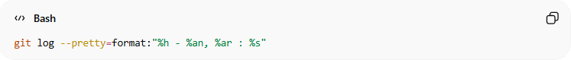
git log --pretty=format:"%h - %an, %ar : %s"

🧠 Simple Definition
# Source: AI Source: Provided by: [Data Path: Persons Table -> ID Column: 1, Name_En Column: Motasem Essam] -> From: [ChatGPT] on [3/6/2026]
format.pretty oneline
“Make git log show one commit per line by default.”

Set Default Merge Tool
# Source: AI Source: Provided by: [Data Path: Persons Table -> ID Column: 1, Name_En Column: Motasem Essam] -> From: [ChatGPT] on [3/6/2026]
git config --global merge.tool vscode
✅ Sets VS Code as your merge conflict resolution tool.

🔹 What Is a Merge Tool?
# Source: AI Source: Provided by: [Data Path: Persons Table -> ID Column: 1, Name_En Column: Motasem Essam] -> From: [ChatGPT] on [3/6/2026]
When a merge conflict happens (for example during git merge or git pull), Git needs a tool to help you resolve the conflict.
A merge tool shows:
- 🟢 Your version
- 🔵 Incoming version
- 📝 Final result (what you choose)

🔹 What This Command Does
# Source: AI Source: Provided by: [Data Path: Persons Table -> ID Column: 1, Name_En Column: Motasem Essam] -> From: [ChatGPT] on [3/6/2026]
git config --global merge.tool vscode
👉 Sets Visual Studio Code as the default tool to resolve merge conflicts.
So when you run:
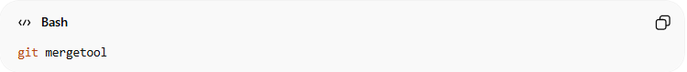
git mergetool
Git will open VS Code automatically.

🔥 Example Scenario
# Source: AI Source: Provided by: [Data Path: Persons Table -> ID Column: 1, Name_En Column: Motasem Essam] -> From: [ChatGPT] on [3/6/2026]
1️⃣ You try to merge:
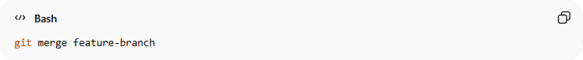
git merge feature-branch
2️⃣ Git shows:
CONFLICT (content): Merge conflict in file.txt
3️⃣ Run:
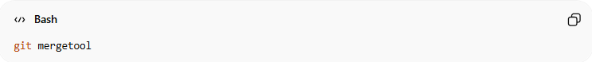
git mergetool
👉 VS Code opens and shows a merge editor like this:
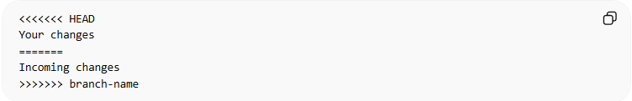
<<<<<<< HEAD
Your changes
=======
Incoming changes
>>>>>>> branch-name

And VS Code gives you buttons like:
- Accept Current
- Accept Incoming
- Accept Both

🔹 Why Use VS Code?
# Source: AI Source: Provided by: [Data Path: Persons Table -> ID Column: 1, Name_En Column: Motasem Essam] -> From: [ChatGPT] on [3/6/2026]
- ✅ Visual conflict resolution
- ✅ Easy buttons to choose changes
- ✅ Clear side-by-side comparison
- ✅ Faster than manual editing

🔹 Why --global?
# Source: AI Source: Provided by: [Data Path: Persons Table -> ID Column: 1, Name_En Column: Motasem Essam] -> From: [ChatGPT] on [3/6/2026]
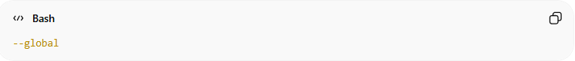
--global
Means:
- Use VS Code for all repositories on your computer
- Saved in:
~/.gitconfig

🔥 Important (Sometimes Needed)
# Source: AI Source: Provided by: [Data Path: Persons Table -> ID Column: 1, Name_En Column: Motasem Essam] -> From: [ChatGPT] on [3/6/2026]
Sometimes you also need to configure the command path:
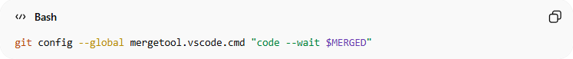
git config --global mergetool.vscode.cmd "code --wait $MERGED"
--wait is important because:
👉 Git waits until you close VS Code before continuing.

🧠 Simple Definition
# Source: AI Source: Provided by: [Data Path: Persons Table -> ID Column: 1, Name_En Column: Motasem Essam] -> From: [ChatGPT] on [3/6/2026]
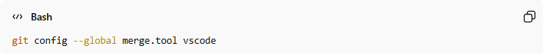
git config --global merge.tool vscode
Means:
“When a merge conflict happens, open VS Code to resolve it.”

Enable Auto-Correct for Mistyped Commands
# Source: AI Source: Provided by: [Data Path: Persons Table -> ID Column: 1, Name_En Column: Motasem Essam] -> From: [ChatGPT] on [3/6/2026]
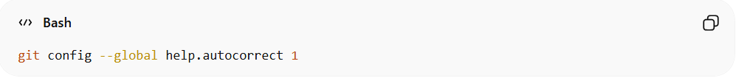
git config --global help.autocorrect 1
✅ If you type git stats, Git will auto-correct to git status.
(You can increase delay time by changing the number.)

🔹 What Does It Do?
# Source: AI Source: Provided by: [Data Path: Persons Table -> ID Column: 1, Name_En Column: Motasem Essam] -> From: [ChatGPT] on [3/6/2026]
If you type a wrong Git command like:
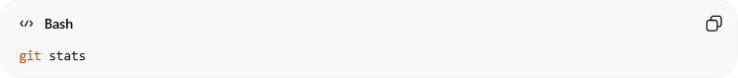
git stats
Git will respond like this:
WARNING: You called a Git command named 'stats', which does not exist.
Continuing in 0.1 seconds, assuming that you meant 'status'.
Then it automatically runs:
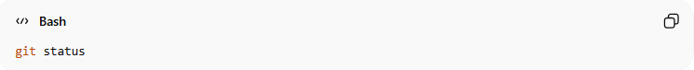
git status

🔹 What Does the Number 1 Mean?
# Source: AI Source: Provided by: [Data Path: Persons Table -> ID Column: 1, Name_En Column: Motasem Essam] -> From: [ChatGPT] on [3/6/2026]
The number is a delay time in tenths of a second.
So:
help.autocorrect 1
Means:
- Wait 0.1 seconds
- Then run the corrected command automatically

🔹 Increase Delay Time
# Source: AI Source: Provided by: [Data Path: Persons Table -> ID Column: 1, Name_En Column: Motasem Essam] -> From: [ChatGPT] on [3/6/2026]
If you want more time to cancel:
git config --global help.autocorrect 10
That means:
- Wait 1 second before auto-running

🔹 If You Want It Instant (No Delay)
# Source: AI Source: Provided by: [Data Path: Persons Table -> ID Column: 1, Name_En Column: Motasem Essam] -> From: [ChatGPT] on [3/6/2026]
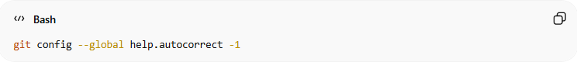
git config --global help.autocorrect -1
⚠️ This runs the corrected command immediately (no warning).

🔹 Why Is This Useful?
# Source: AI Source: Provided by: [Data Path: Persons Table -> ID Column: 1, Name_En Column: Motasem Essam] -> From: [ChatGPT] on [3/6/2026]
- ✅ Saves typing time
- ✅ Fixes small spelling mistakes
- ✅ Helpful for beginners
- ✅ Speeds up workflow

🔹 Why --global?
# Source: AI Source: Provided by: [Data Path: Persons Table -> ID Column: 1, Name_En Column: Motasem Essam] -> From: [ChatGPT] on [3/6/2026]
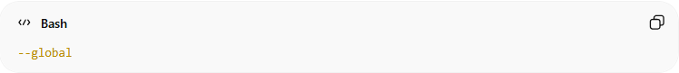
--global
Applies to:
- All repositories on your computer
- Stored in:
~/.gitconfig

🧠 Simple Definition
# Source: AI Source: Provided by: [Data Path: Persons Table -> ID Column: 1, Name_En Column: Motasem Essam] -> From: [ChatGPT] on [3/6/2026]
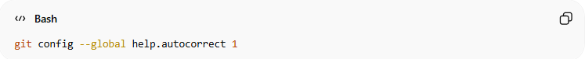
git config --global help.autocorrect 1
Means:
“If I mistype a Git command, automatically fix it after a short delay.”

🔥 Example Test
# Source: AI Source: Provided by: [Data Path: Persons Table -> ID Column: 1, Name_En Column: Motasem Essam] -> From: [ChatGPT] on [3/6/2026]
Try this after enabling:
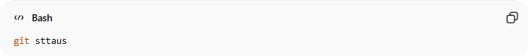
git sttaus
You’ll see Git correct it to:
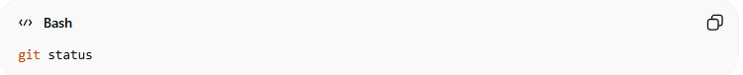
git status

Set Default Diff Tool
# Source: AI Source: Provided by: [Data Path: Persons Table -> ID Column: 1, Name_En Column: Motasem Essam] -> From: [ChatGPT] on [3/6/2026]
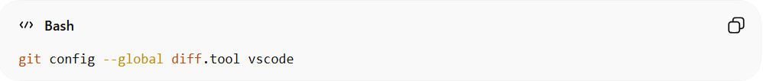
git config --global diff.tool vscode
✅ Opens diffs in VS Code instead of terminal.

🔹 What Is a Diff Tool?
# Source: AI Source: Provided by: [Data Path: Persons Table -> ID Column: 1, Name_En Column: Motasem Essam] -> From: [ChatGPT] on [3/6/2026]
A diff tool shows the differences between:
- Modified files
- Two commits
- Two branches
- Working directory vs staging
Normally, when you run:
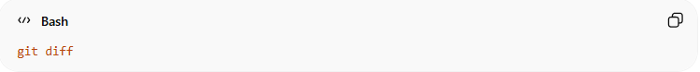
git diff
Git shows differences in the terminal like this:
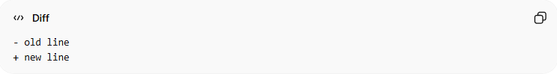
- old line
+ new line
That works, but it’s not very visual.

🔹 What This Command Does
# Source: AI Source: Provided by: [Data Path: Persons Table -> ID Column: 1, Name_En Column: Motasem Essam] -> From: [ChatGPT] on [3/6/2026]
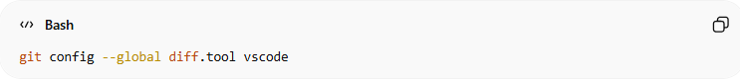
git config --global diff.tool vscode
👉 Sets Visual Studio Code as the default tool for viewing diffs.
So when you run:
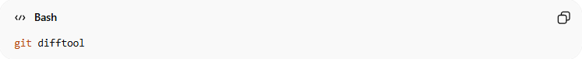
git difftool
Git opens VS Code and shows a side-by-side comparison instead of terminal text.

🔥 Example Workflow
# Source: AI Source: Provided by: [Data Path: Persons Table -> ID Column: 1, Name_En Column: Motasem Essam] -> From: [ChatGPT] on [3/6/2026]
1️⃣ Modify a file:
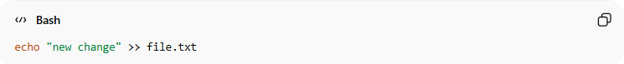
echo "new change" >> file.txt
2️⃣ Run:
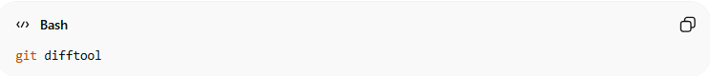
git difftool
👉 VS Code opens and shows:
Left side → Old version
Right side → New version
Much easier to read ✅

🔹 Important (Usually Needed)
# Source: AI Source: Provided by: [Data Path: Persons Table -> ID Column: 1, Name_En Column: Motasem Essam] -> From: [ChatGPT] on [3/6/2026]
You may also need to configure the command:
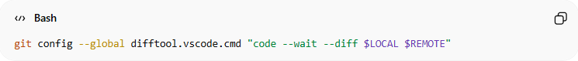
git config --global difftool.vscode.cmd "code --wait --diff $LOCAL $REMOTE"
Explanation:
- --diff → Opens side-by-side diff view
- --wait → Git waits until VS Code closes

🔹 Difference Between git diff and git difftool
# Source: AI Source: Provided by: [Data Path: Persons Table -> ID Column: 1, Name_En Column: Motasem Essam] -> From: [ChatGPT] on [3/6/2026]
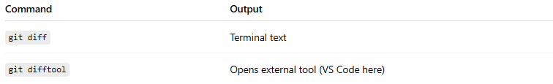
Command | Output
git diff | Terminal text
git difftool | Opens external tool (VS Code here)

🔹 Why Use --global?
# Source: AI Source: Provided by: [Data Path: Persons Table -> ID Column: 1, Name_En Column: Motasem Essam] -> From: [ChatGPT] on [3/6/2026]
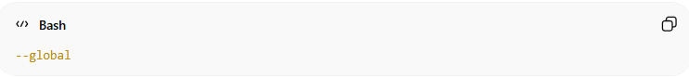
--global
Means:
- Apply to all repositories
- Saved in:
~/.gitconfig

🧠 Simple Definition
# Source: AI Source: Provided by: [Data Path: Persons Table -> ID Column: 1, Name_En Column: Motasem Essam] -> From: [ChatGPT] on [3/6/2026]
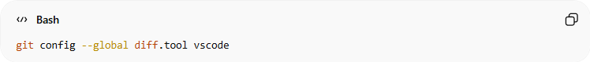
git config --global diff.tool vscode
Means:
“When I use git difftool, open VS Code to view file differences.”

🔥 Diff Tool vs Merge Tool (Quick Difference)
# Source: AI Source: Provided by: [Data Path: Persons Table -> ID Column: 1, Name_En Column: Motasem Essam] -> From: [ChatGPT] on [3/6/2026]
- Diff tool → Compare changes
- Merge tool → Resolve conflicts

Automatically Rebase When Pulling New Branches
# Source: AI Source: Provided by: [Data Path: Persons Table -> ID Column: 1, Name_En Column: Motasem Essam] -> From: [ChatGPT] on [3/6/2026]
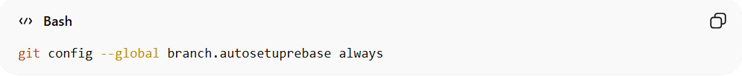
git config --global branch.autosetuprebase always
✅ New branches automatically use rebase instead of merge when pulling.

🔹 First: What Problem Does This Solve?
# Source: AI Source: Provided by: [Data Path: Persons Table -> ID Column: 1, Name_En Column: Motasem Essam] -> From: [ChatGPT] on [3/6/2026]
When you create a new branch that tracks a remote branch:
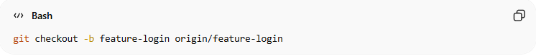
git checkout -b feature-login origin/feature-login
By default, when you later run:
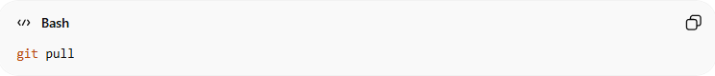
git pull
Git will:
fetch + merge
Which may create merge commits.

🔹 What This Setting Does
# Source: AI Source: Provided by: [Data Path: Persons Table -> ID Column: 1, Name_En Column: Motasem Essam] -> From: [ChatGPT] on [3/6/2026]
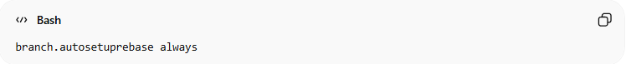
branch.autosetuprebase always
Means:
“Whenever I create a new tracking branch, configure it to use rebase when pulling.”
So now:
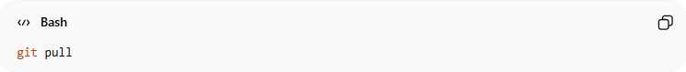
git pull
Will automatically behave like:
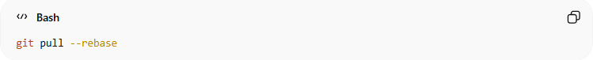
git pull --rebase
Instead of merge.

🔥 What Does "always" Mean?
# Source: AI Source: Provided by: [Data Path: Persons Table -> ID Column: 1, Name_En Column: Motasem Essam] -> From: [ChatGPT] on [3/6/2026]
always =
Apply this behavior to all new branches that track remote branches.

🔹 Example Scenario

Without This Setting ❌
# Source: AI Source: Provided by: [Data Path: Persons Table -> ID Column: 1, Name_En Column: Motasem Essam] -> From: [ChatGPT] on [3/6/2026]
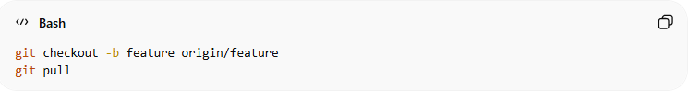
git checkout -b feature origin/feature
git pull
Result:
fetch + merge
May create extra merge commits.

With This Setting ✅
# Source: AI Source: Provided by: [Data Path: Persons Table -> ID Column: 1, Name_En Column: Motasem Essam] -> From: [ChatGPT] on [3/6/2026]
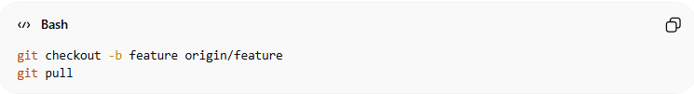
git checkout -b feature origin/feature
git pull
Result:
fetch + rebase
Your commits are moved on top of remote commits.
Cleaner history.

🔹 Important Difference From pull.rebase true
# Source: AI Source: Provided by: [Data Path: Persons Table -> ID Column: 1, Name_En Column: Motasem Essam] -> From: [ChatGPT] on [3/6/2026]
You previously saw:
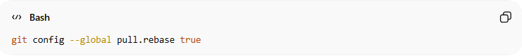
git config --global pull.rebase true
Difference:
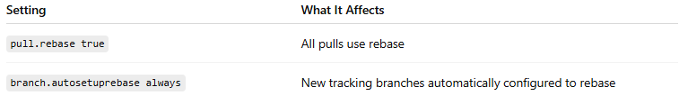
Setting | What It Affects
pull.rebase true | All pulls use rebase
branch.autosetuprebase always | New tracking branches automatically configured to rebase
If you set pull.rebase true, you usually don’t need this one.

🔥 Visual Difference
# Source: AI Source: Provided by: [Data Path: Persons Table -> ID Column: 1, Name_En Column: Motasem Essam] -> From: [ChatGPT] on [3/6/2026]
Merge (Default)
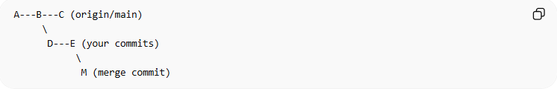
A---B---C (origin/main)
\
D---E (your commits)
\
M (merge commit)
Rebase
A---B---C---D'---E'
No merge commit. Cleaner.

🔹 Why Use --global?
# Source: AI Source: Provided by: [Data Path: Persons Table -> ID Column: 1, Name_En Column: Motasem Essam] -> From: [ChatGPT] on [3/6/2026]
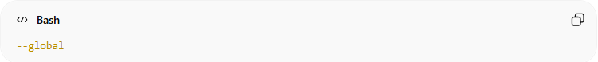
--global
Applies to:
- All new repositories
- Stored in:
~/.gitconfig

🧠 Simple Definition
# Source: AI Source: Provided by: [Data Path: Persons Table -> ID Column: 1, Name_En Column: Motasem Essam] -> From: [ChatGPT] on [3/6/2026]
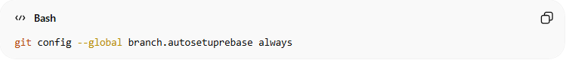
git config --global branch.autosetuprebase always
Means:
“When I create new branches that track a remote branch, use rebase instead of merge when I pull.”

⚠️ Important Note
# Source: AI Source: Provided by: [Data Path: Persons Table -> ID Column: 1, Name_En Column: Motasem Essam] -> From: [ChatGPT] on [3/6/2026]
Modern Git setups usually prefer:
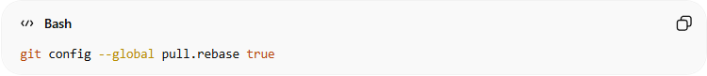
git config --global pull.rebase true
It’s simpler and clearer.

Set Default File Permission Handling (Important on Windows)
# Source: AI Source: Provided by: [Data Path: Persons Table -> ID Column: 1, Name_En Column: Motasem Essam] -> From: [ChatGPT] on [3/6/2026]
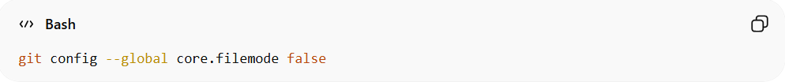
git config --global core.filemode false
✅ Prevents Git from detecting permission changes as file modifications.

🔹 What Is core.filemode?
# Source: AI Source: Provided by: [Data Path: Persons Table -> ID Column: 1, Name_En Column: Motasem Essam] -> From: [ChatGPT] on [3/6/2026]
Git normally tracks:
- File content ✅
- File permissions (executable bit) ✅ (on Linux/macOS)
On Unix systems, a file can be:
- Normal file
- Executable file (chmod +x)
Git detects that change.

🔥 The Problem on Windows
# Source: AI Source: Provided by: [Data Path: Persons Table -> ID Column: 1, Name_En Column: Motasem Essam] -> From: [ChatGPT] on [3/6/2026]
Windows does NOT use Unix-style executable permissions.
So sometimes Git may detect fake permission changes like:
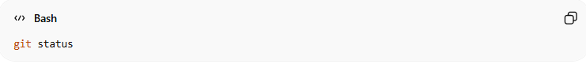
git status
Output:
modified: file.txt
Even though you didn’t change the file content — only file mode changed.
This creates annoying false modifications.

🔹 What core.filemode false Does
# Source: AI Source: Provided by: [Data Path: Persons Table -> ID Column: 1, Name_En Column: Motasem Essam] -> From: [ChatGPT] on [3/6/2026]
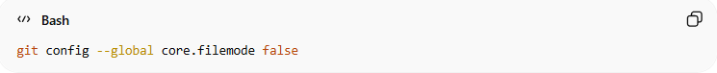
git config --global core.filemode false
Means:
“Ignore file permission changes. Only track content changes.”
Now Git will:
- ❌ Ignore chmod changes
- ✅ Only detect real content edits

🔹 Why Is It Important on Windows?
# Source: AI Source: Provided by: [Data Path: Persons Table -> ID Column: 1, Name_En Column: Motasem Essam] -> From: [ChatGPT] on [3/6/2026]
Because:
- Windows file systems don’t properly support Unix executable bits
- Git may think permissions changed every time
- Causes unnecessary modified files in git status
So Windows users usually set:
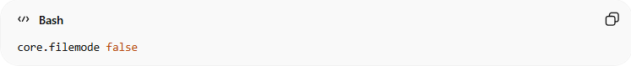
core.filemode false

🔹 On Linux/macOS?
# Source: AI Source: Provided by: [Data Path: Persons Table -> ID Column: 1, Name_En Column: Motasem Essam] -> From: [ChatGPT] on [3/6/2026]
Usually keep:
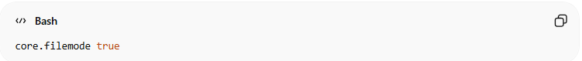
core.filemode true
Because executable permissions matter there.
Example:
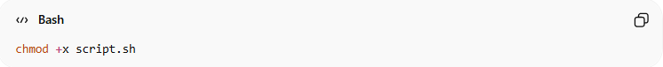
chmod +x script.sh
That change should be tracked.

🔥 Example Scenario
# Source: AI Source: Provided by: [Data Path: Persons Table -> ID Column: 1, Name_En Column: Motasem Essam] -> From: [ChatGPT] on [3/6/2026]
Without setting:
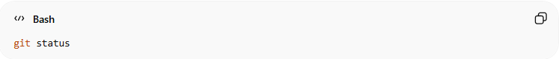
git status
Shows:
modified: script.sh
After setting:
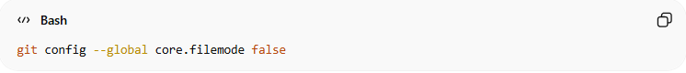
git config --global core.filemode false
Now:
nothing to commit
Because only permission changed, not content.

🔹 Why --global?
# Source: AI Source: Provided by: [Data Path: Persons Table -> ID Column: 1, Name_En Column: Motasem Essam] -> From: [ChatGPT] on [3/6/2026]
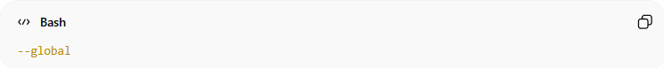
--global
Applies to:
- All repositories on your computer
- Saved in:
~/.gitconfig

🧠 Simple Definition
# Source: AI Source: Provided by: [Data Path: Persons Table -> ID Column: 1, Name_En Column: Motasem Essam] -> From: [ChatGPT] on [3/6/2026]
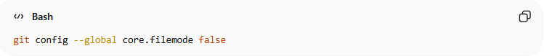
git config --global core.filemode false
Means:
“On Windows, ignore permission changes and only track file content changes.”

🔥 Quick Summary
# Source: AI Source: Provided by: [Data Path: Persons Table -> ID Column: 1, Name_En Column: Motasem Essam] -> From: [ChatGPT] on [3/6/2026]
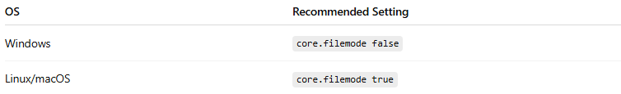
OS | Recommended Setting
Windows | core.filemode false
Linux/macOS | core.filemode true

Enable Long File Paths (Windows)
# Source: AI Source: Provided by: [Data Path: Persons Table -> ID Column: 1, Name_En Column: Motasem Essam] -> From: [ChatGPT] on [3/6/2026]
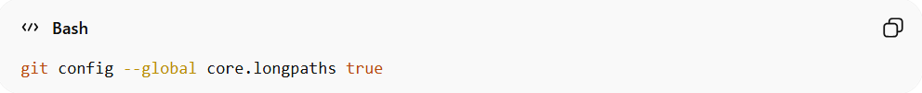
git config --global core.longpaths true
✅ Fixes “filename too long” errors on Windows.

🔹 The Problem on Windows
# Source: AI Source: Provided by: [Data Path: Persons Table -> ID Column: 1, Name_En Column: Motasem Essam] -> From: [ChatGPT] on [3/6/2026]
Older Windows systems have a maximum file path length of 260 characters.
Example path:
C:\Users\Tom\Desktop\Project\src\components\authentication\login\controllers\services\validation\helpers\file.txt
If the full path becomes longer than 260 characters, Git may show an error like:
error: Filename too long
fatal: unable to checkout working tree
This often happens when:
- Cloning large projects
- Using frameworks with deep folder structures
- Working with node_modules in JavaScript projects

🔹 What This Command Does
# Source: AI Source: Provided by: [Data Path: Persons Table -> ID Column: 1, Name_En Column: Motasem Essam] -> From: [ChatGPT] on [3/6/2026]
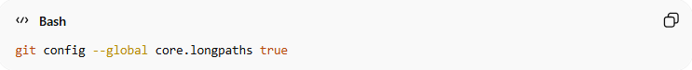
git config --global core.longpaths true
It tells Git:
“Allow file paths longer than the Windows 260-character limit.”
So Git can:
- Clone repositories with deep folder structures
- Checkout long file paths
- Avoid filename too long errors

🔹 Why --global?
# Source: AI Source: Provided by: [Data Path: Persons Table -> ID Column: 1, Name_En Column: Motasem Essam] -> From: [ChatGPT] on [3/6/2026]
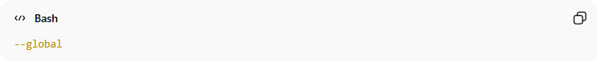
--global
Means:
- Apply to all Git repositories on your computer
- Saved in:
~/.gitconfig

🔹 Example Problem
# Source: AI Source: Provided by: [Data Path: Persons Table -> ID Column: 1, Name_En Column: Motasem Essam] -> From: [ChatGPT] on [3/6/2026]
Without this setting:
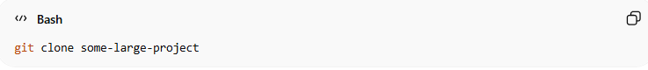
git clone some-large-project
You may see:
error: Filename too long
After enabling:
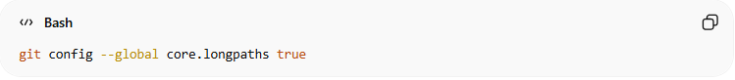
git config --global core.longpaths true
Git can handle long paths normally.

🔹 Important Note
# Source: AI Source: Provided by: [Data Path: Persons Table -> ID Column: 1, Name_En Column: Motasem Essam] -> From: [ChatGPT] on [3/6/2026]
Sometimes Windows itself must allow long paths.
If the error still appears, Windows may need this policy enabled:
Enable Win32 long paths
But in most modern Windows versions, Git’s core.longpaths true is enough.

🧠 Simple Definition
# Source: AI Source: Provided by: [Data Path: Persons Table -> ID Column: 1, Name_En Column: Motasem Essam] -> From: [ChatGPT] on [3/6/2026]
git config --global core.longpaths true
Means:
Allow Git to work with very long file paths on Windows and prevent “filename too long” errors.

✅ Quick tip:
# Source: AI Source: Provided by: [Data Path: Persons Table -> ID Column: 1, Name_En Column: Motasem Essam] -> From: [ChatGPT] on [3/6/2026]
This setting is very useful when working with:
- JavaScript / Node.js projects
- Large frameworks
- Deep folder structures.

Set Default CRLF Handling (Windows Recommended)
# Source: AI Source: Provided by: [Data Path: Persons Table -> ID Column: 1, Name_En Column: Motasem Essam] -> From: [ChatGPT] on [3/6/2026]
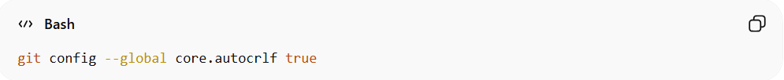
git config --global core.autocrlf true
✅ Automatically converts line endings between Windows and Linux formats.
For Linux/macOS:
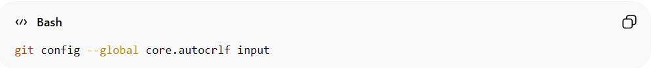
git config --global core.autocrlf input

🔹 First: What Is CRLF?
# Source: AI Source: Provided by: [Data Path: Persons Table -> ID Column: 1, Name_En Column: Motasem Essam] -> From: [ChatGPT] on [3/6/2026]
Different operating systems use different line endings.
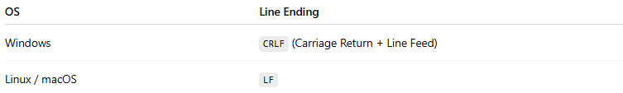
OS | Line Ending
Windows | CRLF (Carriage Return + Line Feed)
Linux / macOS | LF
Example:
Windows:
Hello World\r\n
Linux/macOS:
Hello World\n
This difference can cause problems in Git repositories shared between different systems.

🔹 The Problem Without This Setting
# Source: AI Source: Provided by: [Data Path: Persons Table -> ID Column: 1, Name_En Column: Motasem Essam] -> From: [ChatGPT] on [3/6/2026]
If Windows and Linux developers work on the same repository:
- Windows saves files with CRLF
- Linux saves files with LF
Git may think every line changed, producing large diffs like:
1000 lines changed
Even though the content is the same.

🔹 What This Command Does (Windows)
# Source: AI Source: Provided by: [Data Path: Persons Table -> ID Column: 1, Name_En Column: Motasem Essam] -> From: [ChatGPT] on [3/6/2026]
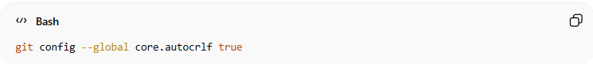
git config --global core.autocrlf true
Git will automatically convert line endings:
When pulling / cloning
Repository (LF) → Working Directory (CRLF)
When committing
Working Directory (CRLF) → Repository (LF)
So the repository always keeps LF, but Windows users edit files with CRLF.

🔹 Visual Workflow
# Source: AI Source: Provided by: [Data Path: Persons Table -> ID Column: 1, Name_En Column: Motasem Essam] -> From: [ChatGPT] on [3/6/2026]
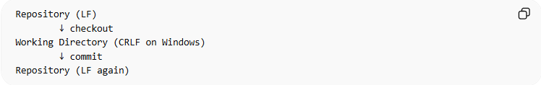
Repository (LF)
↓ checkout
Working Directory (CRLF on Windows)
↓ commit
Repository (LF again)
This keeps the repository consistent across platforms.

🔹 Setting for Linux / macOS
# Source: AI Source: Provided by: [Data Path: Persons Table -> ID Column: 1, Name_En Column: Motasem Essam] -> From: [ChatGPT] on [3/6/2026]
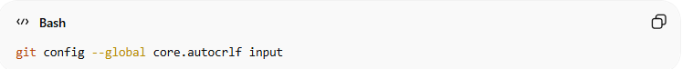
git config --global core.autocrlf input
Behavior:
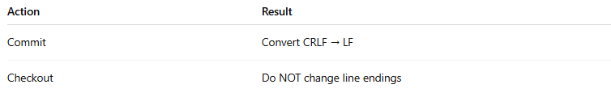
Action | Result
Commit | Convert CRLF → LF
Checkout | Do NOT change line endings
So Linux/macOS users keep LF everywhere.

🔹 Quick Comparison
# Source: AI Source: Provided by: [Data Path: Persons Table -> ID Column: 1, Name_En Column: Motasem Essam] -> From: [ChatGPT] on [3/6/2026]
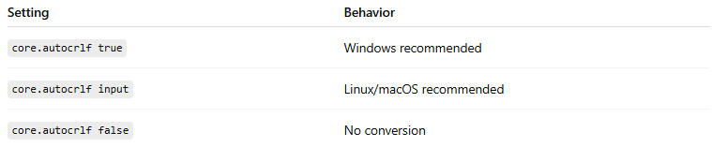
Setting | Behavior
core.autocrlf true | Windows recommended
core.autocrlf input | Linux/macOS recommended
core.autocrlf false | No conversion

🔹 Why Use --global?
# Source: AI Source: Provided by: [Data Path: Persons Table -> ID Column: 1, Name_En Column: Motasem Essam] -> From: [ChatGPT] on [3/6/2026]
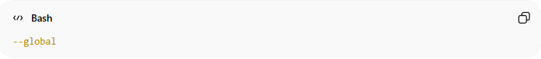
--global
Means:
- Apply to all repositories
- Saved in:
~/.gitconfig

🧠 Simple Definition
# Source: AI Source: Provided by: [Data Path: Persons Table -> ID Column: 1, Name_En Column: Motasem Essam] -> From: [ChatGPT] on [3/6/2026]
git config --global core.autocrlf true
Means:
Automatically convert line endings between Windows (CRLF) and Git repositories (LF).

✅ Recommended setup
# Source: AI Source: Provided by: [Data Path: Persons Table -> ID Column: 1, Name_En Column: Motasem Essam] -> From: [ChatGPT] on [3/6/2026]
Windows:
git config --global core.autocrlf true
Linux/macOS:
git config --global core.autocrlf input

Enable GPG Signing for Commits
# Source: AI Source: Provided by: [Data Path: Persons Table -> ID Column: 1, Name_En Column: Motasem Essam] -> From: [ChatGPT] on [3/6/2026]
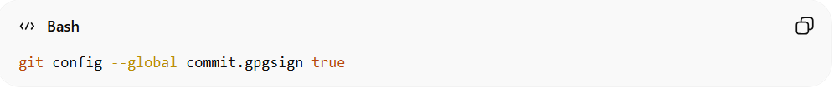
git config --global commit.gpgsign true
✅ Automatically signs all commits with your GPG key.

🔹 What Is GPG Signing?
# Source: AI Source: Provided by: [Data Path: Persons Table -> ID Column: 1, Name_En Column: Motasem Essam] -> From: [ChatGPT] on [3/6/2026]
GPG (GNU Privacy Guard) allows you to digitally sign your commits.
This proves:
- ✅ The commit was really made by you
- ✅ The commit was not modified
- ✅ Your identity is verified
Platforms like GitHub show a “Verified” badge on signed commits.

🔹 What This Command Does
# Source: AI Source: Provided by: [Data Path: Persons Table -> ID Column: 1, Name_En Column: Motasem Essam] -> From: [ChatGPT] on [3/6/2026]
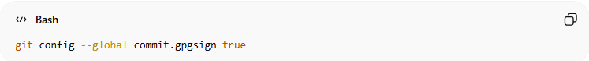
git config --global commit.gpgsign true
It tells Git:
“Automatically sign every commit using my GPG key.”
So every time you run:
git commit -m "Fix login bug"
Git will automatically attach your cryptographic signature.

🔹 Without This Setting
# Source: AI Source: Provided by: [Data Path: Persons Table -> ID Column: 1, Name_En Column: Motasem Essam] -> From: [ChatGPT] on [3/6/2026]
You would need to sign commits manually:
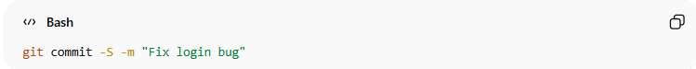
git commit -S -m "Fix login bug"
-S = sign commit.
With the configuration enabled, Git adds -S automatically.

🔹 How It Works Internally
# Source: AI Source: Provided by: [Data Path: Persons Table -> ID Column: 1, Name_En Column: Motasem Essam] -> From: [ChatGPT] on [3/6/2026]
When you commit:
1️⃣ Git creates the commit
2️⃣ Git signs it using your GPG private key
3️⃣ The signature is attached to the commit
Example:
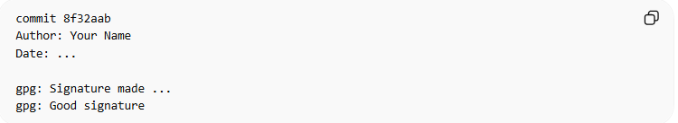
commit 8f32aab
Author: Your Name
Date: ...

gpg: Signature made ...
gpg: Good signature

🔹 Why This Is Important
# Source: AI Source: Provided by: [Data Path: Persons Table -> ID Column: 1, Name_En Column: Motasem Essam] -> From: [ChatGPT] on [3/6/2026]
Benefits:
- 🔐 Security – verifies commit authenticity
- 👤 Identity verification
- 🛡️ Prevents commit spoofing
- ⭐ Shows Verified badge on GitHub
Example on GitHub:
✔ Verified

🔹 Where This Setting Is Stored
# Source: AI Source: Provided by: [Data Path: Persons Table -> ID Column: 1, Name_En Column: Motasem Essam] -> From: [ChatGPT] on [3/6/2026]
Because you used:
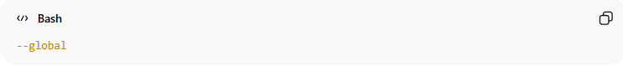
--global
Git saves it in:
~/.gitconfig
So it applies to all repositories on your computer.

🔹 Important Requirement
# Source: AI Source: Provided by: [Data Path: Persons Table -> ID Column: 1, Name_En Column: Motasem Essam] -> From: [ChatGPT] on [3/6/2026]
This only works if you already have a GPG key configured.
You must:
1️⃣ Create a GPG key
2️⃣ Tell Git which key to use
Example:
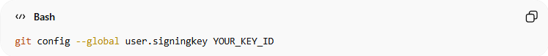
git config --global user.signingkey YOUR_KEY_ID

🧠 Simple Definition
# Source: AI Source: Provided by: [Data Path: Persons Table -> ID Column: 1, Name_En Column: Motasem Essam] -> From: [ChatGPT] on [3/6/2026]
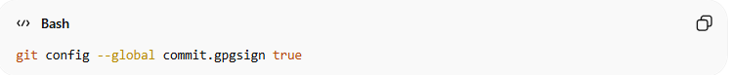
git config --global commit.gpgsign true
Means:
“Automatically sign every Git commit with my GPG key to prove it was created by me.”

Show More Detailed Status Output
# Source: AI Source: Provided by: [Data Path: Persons Table -> ID Column: 1, Name_En Column: Motasem Essam] -> From: [ChatGPT] on [3/6/2026]
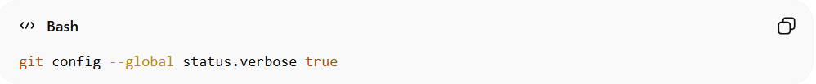
git config --global status.verbose true
✅ Shows full diff in git status.

🔹 What This Setting Does
# Source: AI Source: Provided by: [Data Path: Persons Table -> ID Column: 1, Name_En Column: Motasem Essam] -> From: [ChatGPT] on [3/6/2026]
This configuration makes git status show more detailed information, including the diff (changes) of staged files.
Normally:
git status
Only shows which files changed, like:
modified: file.txt
But it does NOT show the actual changes.

🔹 After Enabling status.verbose
# Source: AI Source: Provided by: [Data Path: Persons Table -> ID Column: 1, Name_En Column: Motasem Essam] -> From: [ChatGPT] on [3/6/2026]
When you run:
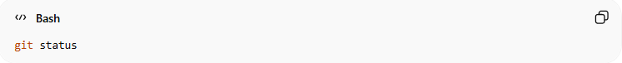
git status
Git will show:
- The changed files
- The actual code differences
Example:
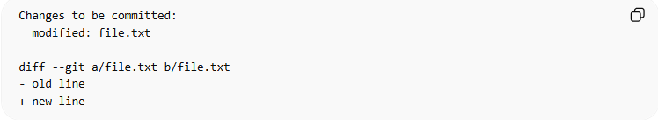
Changes to be committed:
modified: file.txt

diff --git a/file.txt b/file.txt
- old line
+ new line
So you can see what changed without running another command.

🔹 Normal Workflow Without This Setting
# Source: AI Source: Provided by: [Data Path: Persons Table -> ID Column: 1, Name_En Column: Motasem Essam] -> From: [ChatGPT] on [3/6/2026]
You usually need two commands:
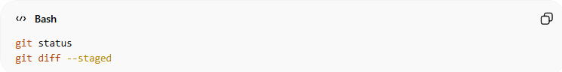
git status
git diff --staged

🔹 With status.verbose true
# Source: AI Source: Provided by: [Data Path: Persons Table -> ID Column: 1, Name_En Column: Motasem Essam] -> From: [ChatGPT] on [3/6/2026]
One command is enough:
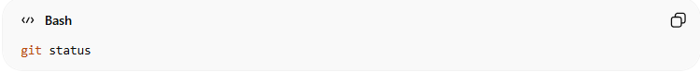
git status
Because Git will include the diff automatically.

🔹 Example
# Source: AI Source: Provided by: [Data Path: Persons Table -> ID Column: 1, Name_En Column: Motasem Essam] -> From: [ChatGPT] on [3/6/2026]
1️⃣ Modify a file
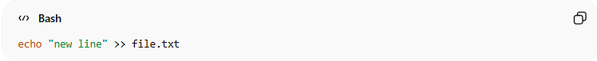
echo "new line" >> file.txt
2️⃣ Stage it
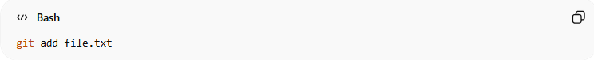
git add file.txt
3️⃣ Run status
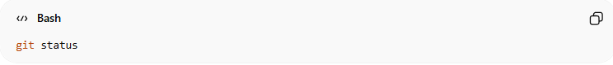
git status
Output will include:
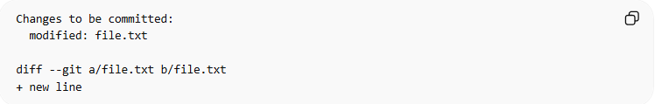
Changes to be committed:
modified: file.txt

diff --git a/file.txt b/file.txt
+ new line

🔹 Why Use --global?
# Source: AI Source: Provided by: [Data Path: Persons Table -> ID Column: 1, Name_En Column: Motasem Essam] -> From: [ChatGPT] on [3/6/2026]
--global
Means:
- Apply to all repositories
- Stored in:
~/.gitconfig

🧠 Simple Definition
# Source: AI Source: Provided by: [Data Path: Persons Table -> ID Column: 1, Name_En Column: Motasem Essam] -> From: [ChatGPT] on [3/6/2026]
git config --global status.verbose true
Means:
Make git status display detailed changes (diffs) instead of only listing modified files.

✅ Important note:
# Source: AI Source: Provided by: [Data Path: Persons Table -> ID Column: 1, Name_En Column: Motasem Essam] -> From: [ChatGPT] on [3/6/2026]
This shows the diff of staged changes, similar to:
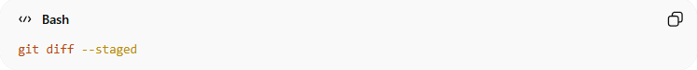
git diff --staged

Improve Rename Detection
# Source: AI Source: Provided by: [Data Path: Persons Table -> ID Column: 1, Name_En Column: Motasem Essam] -> From: [ChatGPT] on [3/6/2026]
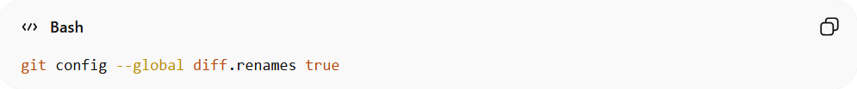
git config --global diff.renames true
✅ Git better detects renamed files.

🔹 What Problem Does This Solve?
# Source: AI Source: Provided by: [Data Path: Persons Table -> ID Column: 1, Name_En Column: Motasem Essam] -> From: [ChatGPT] on [3/6/2026]
When you rename a file, Git does not actually store a rename operation internally.
Git stores:
- ❌ File deleted
- ❌ New file created
So without rename detection, Git may show something like:
deleted: old_file.txt
new file: new_file.txt
Even if the file was just renamed.

🔹 What This Setting Does
# Source: AI Source: Provided by: [Data Path: Persons Table -> ID Column: 1, Name_En Column: Motasem Essam] -> From: [ChatGPT] on [3/6/2026]
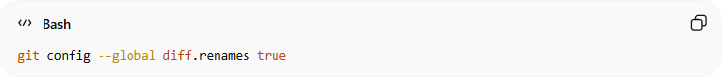
git config --global diff.renames true
It tells Git:
“Try to detect when a file was renamed instead of deleted and recreated.”
Git compares the content similarity between files and decides if it is a rename.

🔹 Example Without Rename Detection
# Source: AI Source: Provided by: [Data Path: Persons Table -> ID Column: 1, Name_En Column: Motasem Essam] -> From: [ChatGPT] on [3/6/2026]
You rename a file:
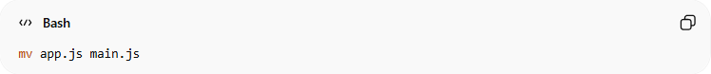
mv app.js main.js
Then run:
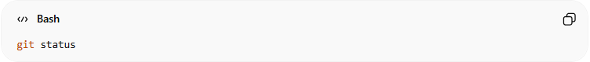
git status
Git may show:
deleted: app.js
new file: main.js

🔹 Example With Rename Detection Enabled
# Source: AI Source: Provided by: [Data Path: Persons Table -> ID Column: 1, Name_En Column: Motasem Essam] -> From: [ChatGPT] on [3/6/2026]
Git detects the rename:
renamed: app.js -> main.js
Much clearer and easier to understand.

🔹 How Git Detects Renames
# Source: AI Source: Provided by: [Data Path: Persons Table -> ID Column: 1, Name_En Column: Motasem Essam] -> From: [ChatGPT] on [3/6/2026]
Git compares file content.
Example:
app.js (95% same content)
main.js
If similarity is high enough, Git marks it as:
rename detected

🔹 Where This Setting Helps Most
# Source: AI Source: Provided by: [Data Path: Persons Table -> ID Column: 1, Name_En Column: Motasem Essam] -> From: [ChatGPT] on [3/6/2026]
This improves output for commands like:
- git diff
- git log
- git show
- git status
Example:
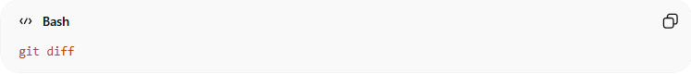
git diff
Instead of showing a delete + new file, Git shows:
rename from app.js
rename to main.js

🔹 Why Use --global?
# Source: AI Source: Provided by: [Data Path: Persons Table -> ID Column: 1, Name_En Column: Motasem Essam] -> From: [ChatGPT] on [3/6/2026]
--global
This means the setting applies to:
- All repositories on your machine
Stored in:
~/.gitconfig

🧠 Simple Definition
# Source: AI Source: Provided by: [Data Path: Persons Table -> ID Column: 1, Name_En Column: Motasem Essam] -> From: [ChatGPT] on [3/6/2026]
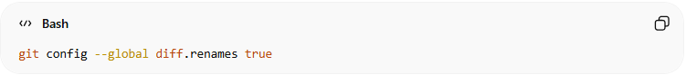
git config --global diff.renames true
Means:
Tell Git to automatically detect when files are renamed instead of showing them as deleted and recreated.

✅ Important note:
# Source: AI Source: Provided by: [Data Path: Persons Table -> ID Column: 1, Name_En Column: Motasem Essam] -> From: [ChatGPT] on [3/6/2026]
Git can detect renames even without this setting, but enabling it improves the diff output and accuracy.

🔹 Configuration Editor

⚙️ What is Configuration Editor
# Source: AI Source: Provided by: [Data Path: Persons Table -> ID Column: 1, Name_En Column: Motasem Essam] -> From: [ChatGPT] on [3/6/2026]
A Configuration Editor in Git is a tool that lets you open and edit Git’s configuration file directly instead of changing settings with individual commands.
In simple terms:
👉 It is an editor used to view and modify Git settings stored in configuration files.

📘 What the Git Configuration Editor Does
# Source: AI Source: Provided by: [Data Path: Persons Table -> ID Column: 1, Name_En Column: Motasem Essam] -> From: [ChatGPT] on [3/6/2026]
The configuration editor allows you to:
- View all Git settings
- Modify existing settings
- Add new configuration options
- Remove configuration values
Instead of writing many commands like:
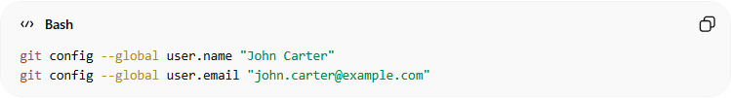
git config --global user.name "John Carter"
git config --global user.email "john.carter@example.com"
You can open the configuration file and edit it manually.

📂 Where Git Configuration Is Stored
# Source: AI Source: Provided by: [Data Path: Persons Table -> ID Column: 1, Name_En Column: Motasem Essam] -> From: [ChatGPT] on [3/6/2026]
Git stores configuration in text files.
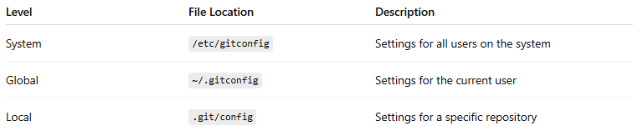
Level | File Location | Description
System | /etc/gitconfig | Settings for all users on the system
Global | ~/.gitconfig | Settings for the current user
Local | .git/config | Settings for a specific repository

🧪 Example: Opening the Configuration Editor
# Source: AI Source: Provided by: [Data Path: Persons Table -> ID Column: 1, Name_En Column: Motasem Essam] -> From: [ChatGPT] on [3/6/2026]
Run this command:
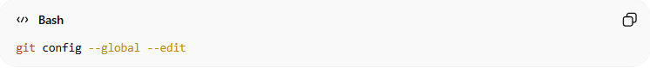
git config --global --edit
Git will open the configuration file in your default editor.
Example configuration file:
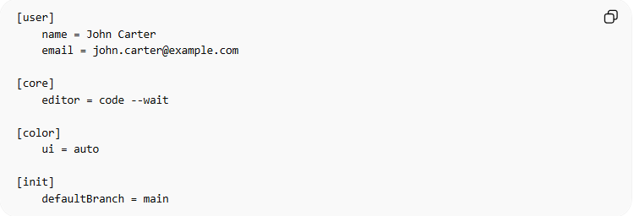
[user]
name = John Carter
email = john.carter@example.com

[core]
editor = code --wait

[color]
ui = auto

[init]
defaultBranch = main
You can edit values directly in this file.

🔧 Example Change in the Editor
# Source: AI Source: Provided by: [Data Path: Persons Table -> ID Column: 1, Name_En Column: Motasem Essam] -> From: [ChatGPT] on [3/6/2026]
Before:
[user]
name = John Carter
After editing:
[user]
name = Michael Brown
Save the file and Git will use the new value.

🎯 Why the Configuration Editor Is Useful
# Source: AI Source: Provided by: [Data Path: Persons Table -> ID Column: 1, Name_En Column: Motasem Essam] -> From: [ChatGPT] on [3/6/2026]
Advantages:
- Edit multiple settings at once
- See all configuration values together
- Easier for advanced users
- Useful when debugging Git settings

🧠 Simple Definition
# Source: AI Source: Provided by: [Data Path: Persons Table -> ID Column: 1, Name_En Column: Motasem Essam] -> From: [ChatGPT] on [3/6/2026]
Configuration Editor (in Git):
A tool that opens Git’s configuration file so you can manually view and edit Git settings.

✅ Short example
# Source: AI Source: Provided by: [Data Path: Persons Table -> ID Column: 1, Name_En Column: Motasem Essam] -> From: [ChatGPT] on [3/6/2026]
Command:
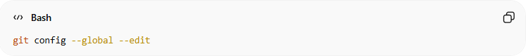
git config --global --edit
Result:
- Opens .gitconfig
- Allows you to edit settings like:
  - username
  - email
  - editor
  - colors
  - default branch

🔹 Changing Colors in Git Output
# Source: AI Source: Provided by: [Data Path: Persons Table -> ID Column: 1, Name_En Column: Motasem Essam] -> From: [ChatGPT] on [3/6/2026]
Git allows you to customize the colors used in its output (such as git status, git diff, and git log). This helps make information easier to read.

Changing Git Colors Through the Terminal

1️⃣ Enable Git Colors
# Source: AI Source: Provided by: [Data Path: Persons Table -> ID Column: 1, Name_En Column: Motasem Essam] -> From: [ChatGPT] on [3/6/2026]
First make sure colors are enabled:
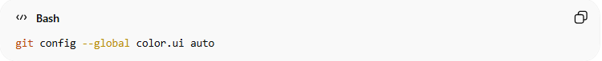
git config --global color.ui auto
This lets Git automatically show colors in the terminal.

2️⃣ Change Specific Git Colors
# Source: AI Source: Provided by: [Data Path: Persons Table -> ID Column: 1, Name_En Column: Motasem Essam] -> From: [ChatGPT] on [3/6/2026]
Git lets you change colors for different parts of its output.
Change color for git status
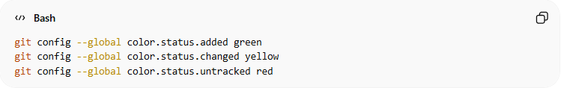
git config --global color.status.added green
git config --global color.status.changed yellow
git config --global color.status.untracked red
Example result in git status:
- Green → staged files
- Yellow → modified files
- Red → untracked files

3️⃣ Change Colors for git diff
# Source: AI Source: Provided by: [Data Path: Persons Table -> ID Column: 1, Name_En Column: Motasem Essam] -> From: [ChatGPT] on [3/6/2026]
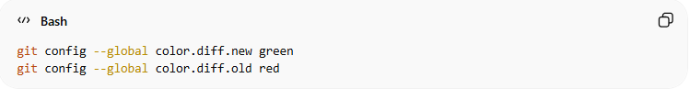
git config --global color.diff.new green
git config --global color.diff.old red
Example:
- Green lines → added code
- Red lines → removed code

4️⃣ Change Colors for git branch
# Source: AI Source: Provided by: [Data Path: Persons Table -> ID Column: 1, Name_En Column: Motasem Essam] -> From: [ChatGPT] on [3/6/2026]
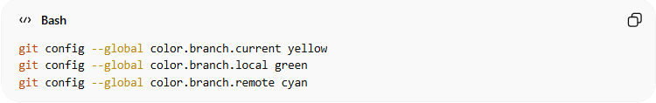
git config --global color.branch.current yellow
git config --global color.branch.local green
git config --global color.branch.remote cyan

5️⃣ Verify the Settings
# Source: AI Source: Provided by: [Data Path: Persons Table -> ID Column: 1, Name_En Column: Motasem Essam] -> From: [ChatGPT] on [3/6/2026]
Run:
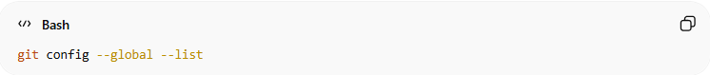
git config --global --list
Example output:
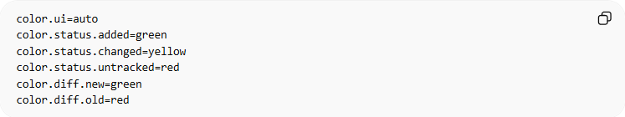
color.ui=auto
color.status.added=green
color.status.changed=yellow
color.status.untracked=red
color.diff.new=green
color.diff.old=red

6️⃣ Test the Colors
# Source: AI Source: Provided by: [Data Path: Persons Table -> ID Column: 1, Name_En Column: Motasem Essam] -> From: [ChatGPT] on [3/6/2026]
Create a small repository to see the colors.
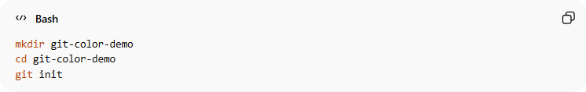
mkdir git-color-demo
cd git-color-demo
git init
Create a file:
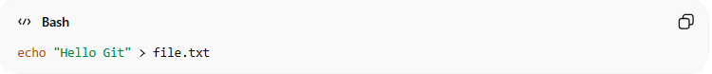
echo "Hello Git" > file.txt
Check status:
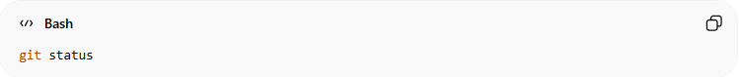
git status
You will see colored output.

🎨 Common Git Colors
# Source: AI Source: Provided by: [Data Path: Persons Table -> ID Column: 1, Name_En Column: Motasem Essam] -> From: [ChatGPT] on [3/6/2026]
Git supports these color names:
- black
- red
- green
- yellow
- blue
- magenta
- cyan
- white
You can also use styles:
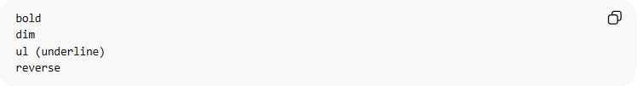
bold
dim
ul (underline)
reverse

Description:
- bold → Makes text bold.
- dim → Makes text faint or dimmed.
- ul (underline) → Underlines the text.
- reverse → Swaps foreground and background colors (inverse).

Example:
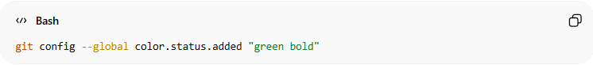
git config --global color.status.added "green bold"

✅ Example Final Configuration
# Source: AI Source: Provided by: [Data Path: Persons Table -> ID Column: 1, Name_En Column: Motasem Essam] -> From: [ChatGPT] on [3/6/2026]
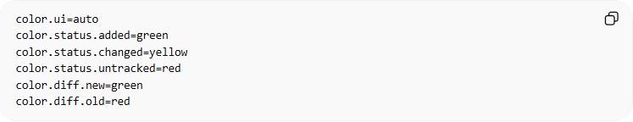
color.ui=auto
color.status.added=green
color.status.changed=yellow
color.status.untracked=red
color.diff.new=green
color.diff.old=red

💡 Tip: Many developers customize Git colors to make code changes easier to read, especially when using git diff and git log.

Changing Git Colors Through the Configuration Editor

1️⃣ Open the Global Configuration Editor
# Source: AI Source: Provided by: [Data Path: Persons Table -> ID Column: 1, Name_En Column: Motasem Essam] -> From: [ChatGPT] on [3/6/2026]
Run the command:
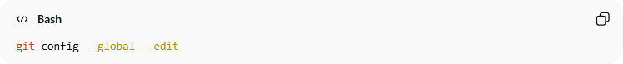
git config --global --edit
This opens the global Git configuration file (.gitconfig) in your default editor.

2️⃣ Add or Modify the Color Section
# Source: AI Source: Provided by: [Data Path: Persons Table -> ID Column: 1, Name_En Column: Motasem Essam] -> From: [ChatGPT] on [3/6/2026]
Inside the editor, you can add a color configuration section like this:
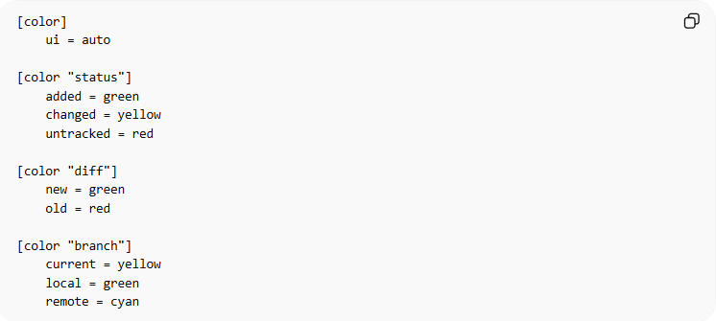
[color]
ui = auto

[color "status"]
added = green
changed = yellow
untracked = red

[color "diff"]
new = green
old = red

[color "branch"]
current = yellow
local = green
remote = cyan

3️⃣ Save and Close the Editor
# Source: AI Source: Provided by: [Data Path: Persons Table -> ID Column: 1, Name_En Column: Motasem Essam] -> From: [ChatGPT] on [3/6/2026]
Save the file and close the editor.
Examples:
- VS Code → Ctrl + S, then close the window
- Nano → Ctrl + X → Y → Enter
- Vim → Esc → type :wq → Enter

4️⃣ Verify the Changes
# Source: AI Source: Provided by: [Data Path: Persons Table -> ID Column: 1, Name_En Column: Motasem Essam] -> From: [ChatGPT] on [3/6/2026]
Run:
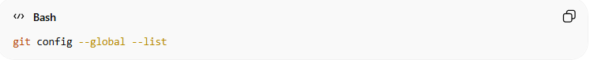
git config --global --list
Example output:
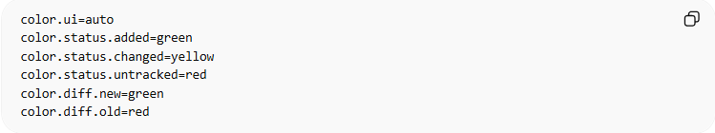
color.ui=auto
color.status.added=green
color.status.changed=yellow
color.status.untracked=red
color.diff.new=green
color.diff.old=red

5️⃣ Test the Color Output
# Source: AI Source: Provided by: [Data Path: Persons Table -> ID Column: 1, Name_En Column: Motasem Essam] -> From: [ChatGPT] on [3/6/2026]
Create a test repository:
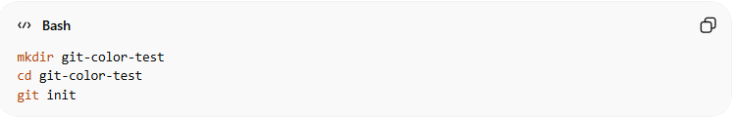
mkdir git-color-test
cd git-color-test
git init
Create a file:
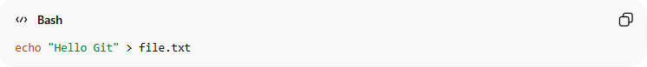
echo "Hello Git" > file.txt
Check status:
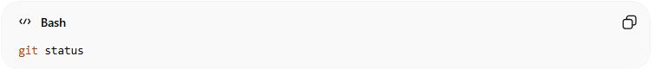
git status
You will see colored output according to the configuration.

🎨 Supported Color Names
# Source: AI Source: Provided by: [Data Path: Persons Table -> ID Column: 1, Name_En Column: Motasem Essam] -> From: [ChatGPT] on [3/6/2026]
Git supports these color names:
- black
- red
- green
- yellow
- blue
- magenta
- cyan
- white
You can also combine styles:
added = "green bold"

🔹 Git Config Help

⚙️ What is Git Config Help
# Source: AI Source: Provided by: [Data Path: Persons Table -> ID Column: 1, Name_En Column: Motasem Essam] -> From: [ChatGPT] on [3/6/2026]
Git Config Help refers to the built-in documentation for the git config command. It explains how Git configuration works, what settings are available, and how to use them.

✅ Key Points
# Source: AI Source: Provided by: [Data Path: Persons Table -> ID Column: 1, Name_En Column: Motasem Essam] -> From: [ChatGPT] on [3/6/2026]
- Provides instructions for viewing, setting, and unsetting Git configuration variables.
- Shows the scope of configurations:
  - System → /etc/gitconfig (all users)
  - Global → ~/.gitconfig (current user)
  - Local → .git/config (current repository)
- Explains options like:
  - --list → list all settings
  - --edit → open configuration editor
  - --get / --get-all → read a specific value
- Offers examples and best practices for configuring Git.

🧪 How to Access Git Config Help
# Source: AI Source: Provided by: [Data Path: Persons Table -> ID Column: 1, Name_En Column: Motasem Essam] -> From: [ChatGPT] on [3/6/2026]
- Open terminal or Git Bash.
- Run:
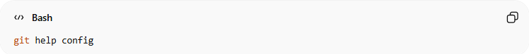
git help config
- Opens the manual page for git config (text-based).
Alternative shortcuts:
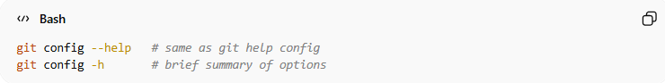
git config --help # same as git help config
git config -h # brief summary of options

💡 Why Use Git Config Help
# Source: AI Source: Provided by: [Data Path: Persons Table -> ID Column: 1, Name_En Column: Motasem Essam] -> From: [ChatGPT] on [3/6/2026]
- Learn how to configure Git globally or per repository.
- Discover advanced options (like color, default branch, editor).
- Helps troubleshoot Git settings when things don’t behave as expected.

Example Information You’ll See
# Source: AI Source: Provided by: [Data Path: Persons Table -> ID Column: 1, Name_En Column: Motasem Essam] -> From: [ChatGPT] on [3/6/2026]
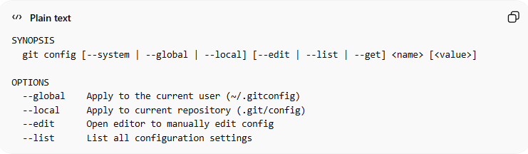
SYNOPSIS
git config [--system | --global | --local] [--edit | --list | --get] <name> [<value>]

OPTIONS
--global Apply to the current user (~/.gitconfig)
--local Apply to current repository (.git/config)
--edit Open editor to manually edit config
--list List all configuration settings

Git Config Help sections
# Source: AI Source: Provided by: [Data Path: Persons Table -> ID Column: 1, Name_En Column: Motasem Essam] -> From: [ChatGPT] on [3/6/2026]
Here’s an explanation of the standard components of a Git help page, describing the purpose of each element (such as NAME, SYNOPSIS, OPTIONS, etc.) to help users quickly understand the structure and locate information in Git documentation.

- NAME is a section that gives the command name and a short description of what the command does.
- SYNOPSIS is a section in the help or man page that shows the general syntax of a command—how to write it correctly and what options or arguments it accepts.
- DESCRIPTION is a section that explains in detail what the command does, including behavior, purpose, and context.
- OPTIONS is a section that lists all the flags, switches, and parameters you can use with a command and explains what each one does.
- EXAMPLES is a section that provides practical examples of how to use the command in real scenarios.
- CONFIGURATION FILES is a section that explains where Git stores configuration settings and the scope of each file (system, global, local).
- SEE ALSO is a section that lists related commands or documentation pages for further reference.
- FILES is a section that specifies the actual files used or affected by the command, such as .gitconfig or .git/config.
- NOTES / AUTHORS / BUGS is a section that contains additional information, warnings, credits, or known issues related to the command.

If you want, I can also make a compact visual table version of these definitions for quick reference—it’s easier to scan and memorize. Do you want me to do that?

In short
# Source: AI Source: Provided by: [Data Path: Persons Table -> ID Column: 1, Name_En Column: Motasem Essam] -> From: [ChatGPT] on [3/6/2026]
Git Config Help is your built-in guide for all Git configuration commands and options.

🔹 How Git Reads Config (Priority Order)
# Source: AI Source: Provided by: [Data Path: Persons Table -> ID Column: 1, Name_En Column: Motasem Essam] -> From: [ChatGPT] on [3/6/2026]
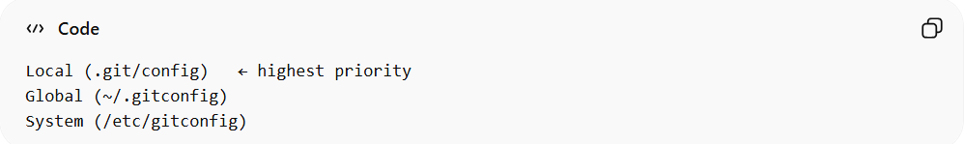
Local (.git/config) ← highest priority
Global (~/.gitconfig)
System (/etc/gitconfig)
If the same setting exists in multiple levels, local overrides global, and global overrides system.

🔹 Paths for each Git configuration level
# Source: AI Source: Provided by: [Data Path: Persons Table -> ID Column: 1, Name_En Column: Motasem Essam] -> From: [ChatGPT] on [3/6/2026]
Here are the paths for each Git configuration level on different operating systems:

🔹 1️⃣ Local Configuration (Highest Priority)
# Source: AI Source: Provided by: [Data Path: Persons Table -> ID Column: 1, Name_En Column: Motasem Essam] -> From: [ChatGPT] on [3/6/2026]
Applies to one repository only.
📍 Stored inside your project folder:
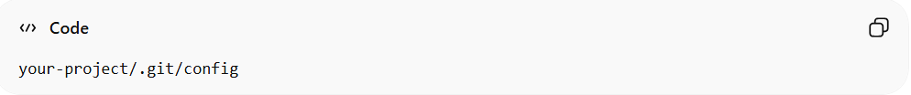
your-project/.git/config
Example on your system:
C:\Users\tom\Desktop\Git_course\.git\config
Or in Git Bash format:
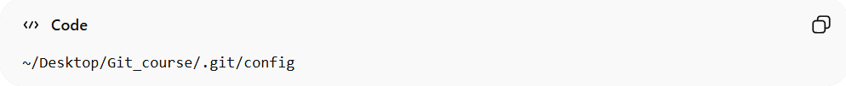
~/Desktop/Git_course/.git/config

🔹 2️⃣ Global Configuration (User Level)
# Source: AI Source: Provided by: [Data Path: Persons Table -> ID Column: 1, Name_En Column: Motasem Essam] -> From: [ChatGPT] on [3/6/2026]
Applies to your user account on the machine.

🪟 Windows:
# Source: AI Source: Provided by: [Data Path: Persons Table -> ID Column: 1, Name_En Column: Motasem Essam] -> From: [ChatGPT] on [3/6/2026]
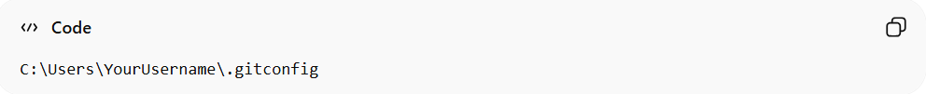
C:\Users\YourUsername\.gitconfig
Example:
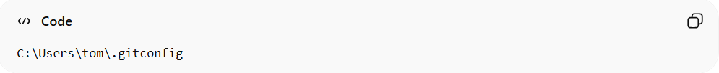
C:\Users\tom\.gitconfig
Git Bash format:
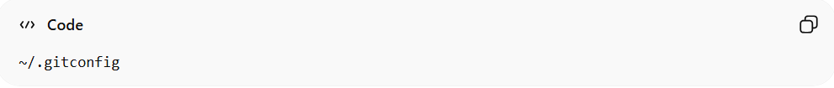
~/.gitconfig

🐧 Linux:
# Source: AI Source: Provided by: [Data Path: Persons Table -> ID Column: 1, Name_En Column: Motasem Essam] -> From: [ChatGPT] on [3/6/2026]
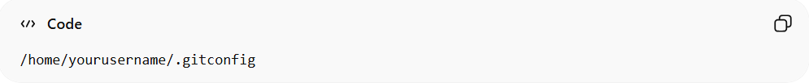
/home/yourusername/.gitconfig
Or
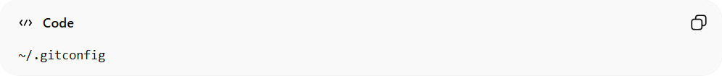
~/.gitconfig

🍎 macOS:
# Source: AI Source: Provided by: [Data Path: Persons Table -> ID Column: 1, Name_En Column: Motasem Essam] -> From: [ChatGPT] on [3/6/2026]
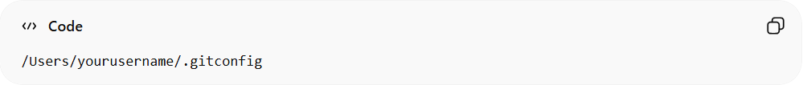
/Users/yourusername/.gitconfig
Or
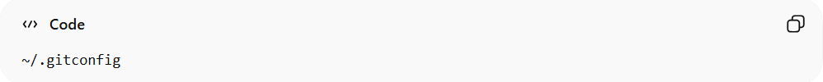
~/.gitconfig

🔹 3️⃣ System Configuration (Lowest Priority)
# Source: AI Source: Provided by: [Data Path: Persons Table -> ID Column: 1, Name_En Column: Motasem Essam] -> From: [ChatGPT] on [3/6/2026]
Applies to all users on the machine.

🪟 Windows:
# Source: AI Source: Provided by: [Data Path: Persons Table -> ID Column: 1, Name_En Column: Motasem Essam] -> From: [ChatGPT] on [3/6/2026]
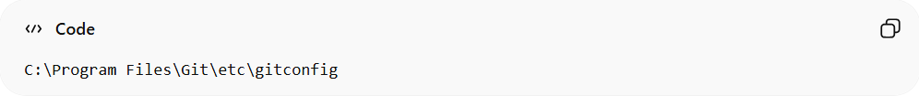
C:\Program Files\Git\etc\gitconfig

🐧 Linux:
# Source: AI Source: Provided by: [Data Path: Persons Table -> ID Column: 1, Name_En Column: Motasem Essam] -> From: [ChatGPT] on [3/6/2026]
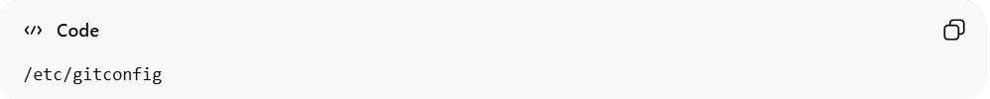
/etc/gitconfig

🍎 macOS:
# Source: AI Source: Provided by: [Data Path: Persons Table -> ID Column: 1, Name_En Column: Motasem Essam] -> From: [ChatGPT] on [3/6/2026]
/etc/gitconfig

🔹 Bonus: See Exact File Locations on Your Machine
# Source: AI Source: Provided by: [Data Path: Persons Table -> ID Column: 1, Name_En Column: Motasem Essam] -> From: [ChatGPT] on [3/6/2026]
Run this command:
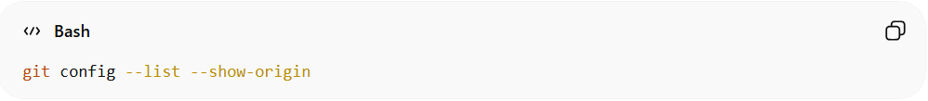
git config --list --show-origin
It will show:
- The setting
- And the exact file path it comes from

🔹 Why Git Config Is Important
# Source: AI Source: Provided by: [Data Path: Persons Table -> ID Column: 1, Name_En Column: Motasem Essam] -> From: [ChatGPT] on [3/6/2026]
- Identifies who makes commits
- Controls behavior and defaults
- Customizes workflow
- Prevents common mistakes

Example

How to See Your Config

Show all settings:
# Source: ScreenShots Source: Provided by: [Persons Table -> ID Column: 1, Name_En Column: Motasem Essam] -> Tool: [Lightshot Program] -> From [Operating System: Windows] on [3/6/2026]
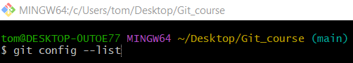
git config --list
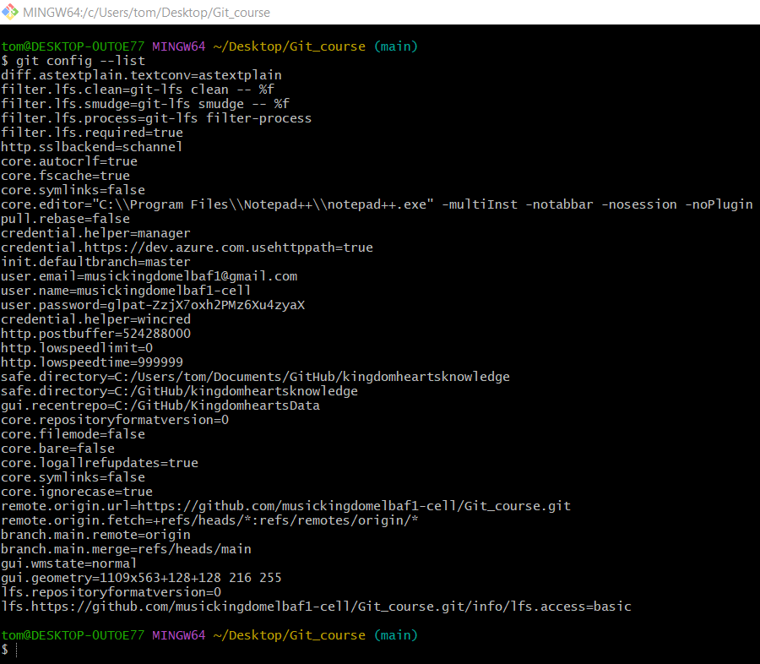

Show only global:
# Source: ScreenShots Source: Provided by: [Persons Table -> ID Column: 1, Name_En Column: Motasem Essam] -> Tool: [Lightshot Program] -> From [Operating System: Windows] on [3/6/2026]
git config --global --list
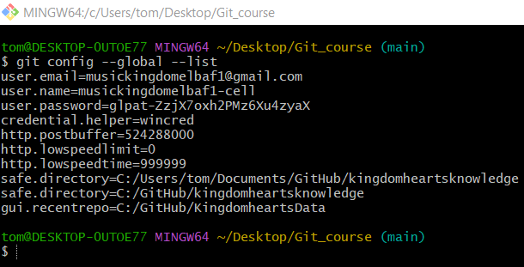

Show where each setting comes from:
# Source: ScreenShots Source: Provided by: [Persons Table -> ID Column: 1, Name_En Column: Motasem Essam] -> Tool: [Lightshot Program] -> From [Operating System: Windows] on [3/6/2026]
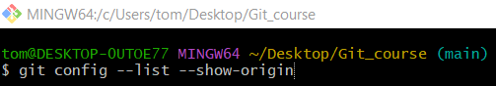
git config --list --show-origin
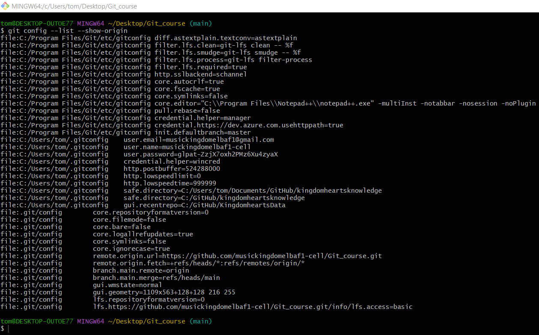

setting your Git user name and email

1️⃣ Set Global Git Username and Email
# Source: ScreenShots Source: Provided by: [Persons Table -> ID Column: 1, Name_En Column: Motasem Essam] -> Tool: [Lightshot Program] -> From [Operating System: Windows] on [3/6/2026]
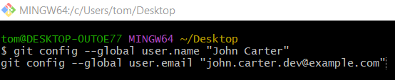
git config --global user.name "John Carter"
git config --global user.email "john.carter.dev@example.com"
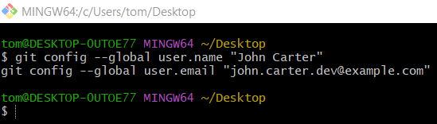

2️⃣ Verify Configuration
# Source: ScreenShots Source: Provided by: [Persons Table -> ID Column: 1, Name_En Column: Motasem Essam] -> Tool: [Lightshot Program] -> From [Operating System: Windows] on [3/6/2026]
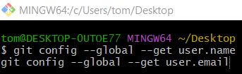
git config --global --get user.name
git config --global --get user.email
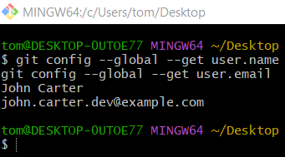

3️⃣ Create a Test Project Folder and Initialize a Git Repository
# Source: ScreenShots Source: Provided by: [Persons Table -> ID Column: 1, Name_En Column: Motasem Essam] -> Tool: [Lightshot Program] -> From [Operating System: Windows] on [3/6/2026]
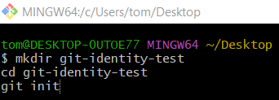
mkdir git-identity-test
cd git-identity-test
git init
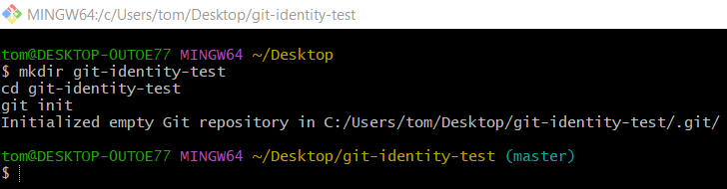

4️⃣ Create a Test File
# Source: ScreenShots Source: Provided by: [Persons Table -> ID Column: 1, Name_En Column: Motasem Essam] -> Tool: [Lightshot Program] -> From [Operating System: Windows] on [3/6/2026]
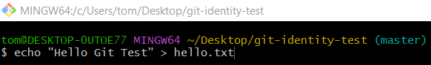
echo "Hello Git Test" > hello.txt
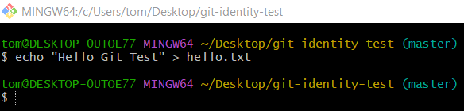
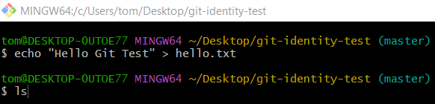
ls
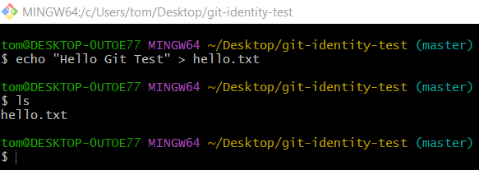

5️⃣ Add File to Git and Make a Commit
# Source: ScreenShots Source: Provided by: [Persons Table -> ID Column: 1, Name_En Column: Motasem Essam] -> Tool: [Lightshot Program] -> From [Operating System: Windows] on [3/6/2026]
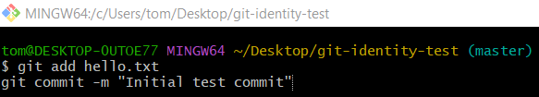
git add hello.txt
git commit -m "Initial test commit"
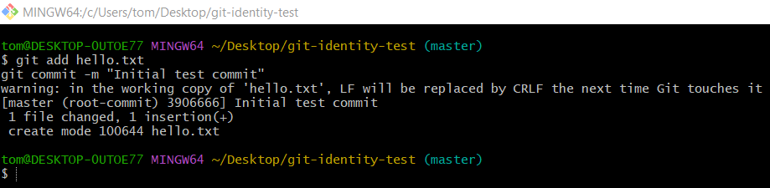

6️⃣ Check Commit Author
# Source: ScreenShots Source: Provided by: [Persons Table -> ID Column: 1, Name_En Column: Motasem Essam] -> Tool: [Lightshot Program] -> From [Operating System: Windows] on [3/6/2026]
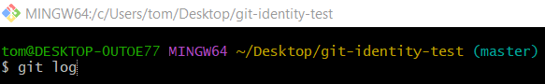
git log
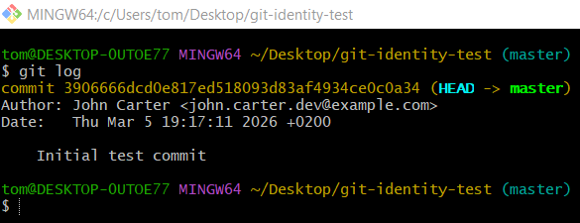

Set default branch name

1️⃣ Set Default Branch Name Globally
# Source: ScreenShots Source: Provided by: [Persons Table -> ID Column: 1, Name_En Column: Motasem Essam] -> Tool: [Lightshot Program] -> From [Operating System: Windows] on [3/6/2026]
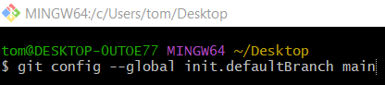
git config --global init.defaultBranch main
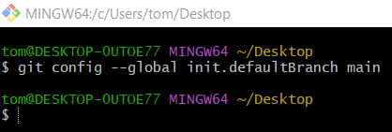

2️⃣ Verify the Configuration
# Source: ScreenShots Source: Provided by: [Persons Table -> ID Column: 1, Name_En Column: Motasem Essam] -> Tool: [Lightshot Program] -> From [Operating System: Windows] on [3/6/2026]
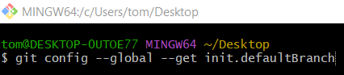
git config --global --get init.defaultBranch
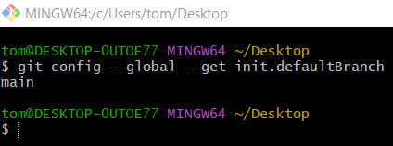

3️⃣ Create a Test Project Folder and Initialize a Git Repository
# Source: ScreenShots Source: Provided by: [Persons Table -> ID Column: 1, Name_En Column: Motasem Essam] -> Tool: [Lightshot Program] -> From [Operating System: Windows] on [3/6/2026]
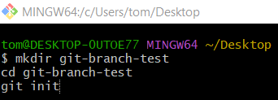
mkdir git-branch-test
cd git-branch-test
git init
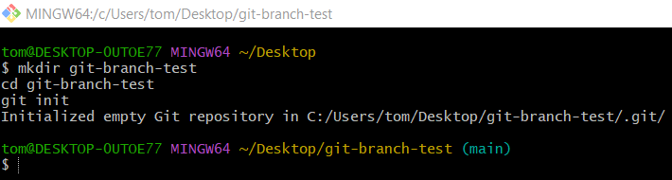

4️⃣ Create a Test File
# Source: ScreenShots Source: Provided by: [Persons Table -> ID Column: 1, Name_En Column: Motasem Essam] -> Tool: [Lightshot Program] -> From [Operating System: Windows] on [3/6/2026]
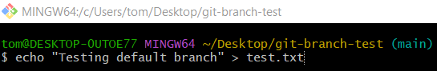
echo "Testing default branch" > test.txt
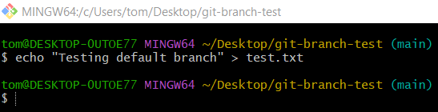
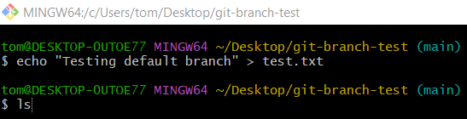
ls
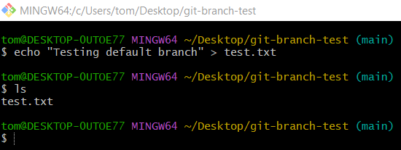

5️⃣ Add File to Git and Make a Commit
# Source: ScreenShots Source: Provided by: [Persons Table -> ID Column: 1, Name_En Column: Motasem Essam] -> Tool: [Lightshot Program] -> From [Operating System: Windows] on [3/6/2026]
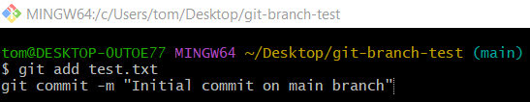
git add test.txt
git commit -m "Initial commit on main branch"
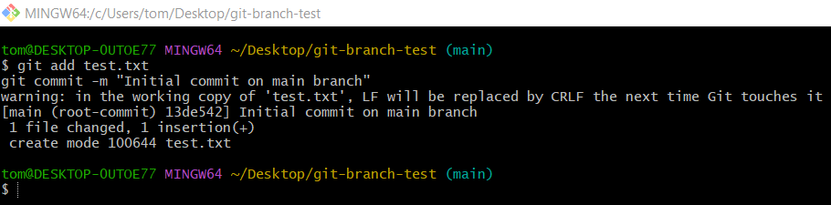
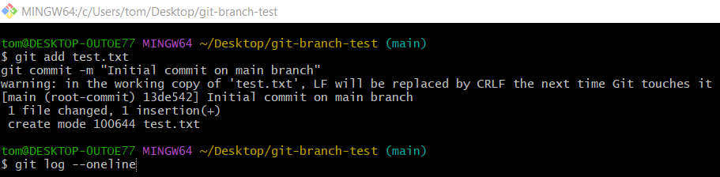
git log --oneline
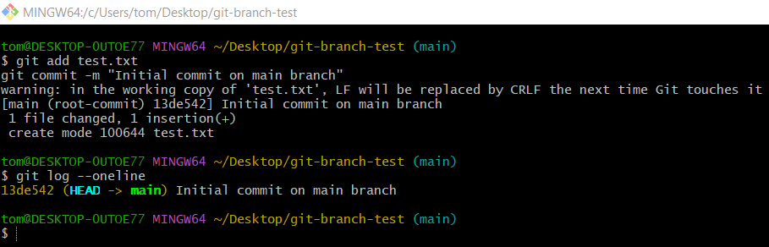

Set Default Git Editor Globally

1️⃣ Set Visual Studio Code as the Default Git Editor
# Source: ScreenShots Source: Provided by: [Persons Table -> ID Column: 1, Name_En Column: Motasem Essam] -> Tool: [Lightshot Program] -> From [Operating System: Windows] on [3/6/2026]
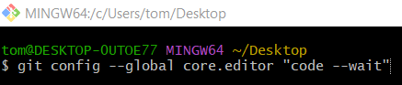
git config --global core.editor "code --wait"
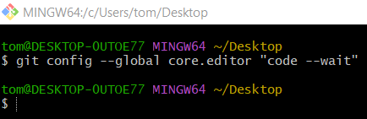

2️⃣ Verify the Editor Setting
# Source: ScreenShots Source: Provided by: [Persons Table -> ID Column: 1, Name_En Column: Motasem Essam] -> Tool: [Lightshot Program] -> From [Operating System: Windows] on [3/6/2026]
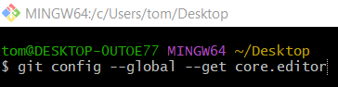
git config --global --get core.editor
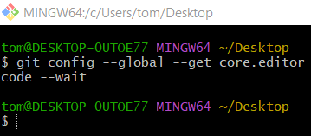

3️⃣ Create a Test Project Folder and Initialize a Git Repository
# Source: ScreenShots Source: Provided by: [Persons Table -> ID Column: 1, Name_En Column: Motasem Essam] -> Tool: [Lightshot Program] -> From [Operating System: Windows] on [3/6/2026]
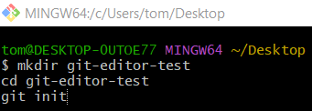
mkdir git-editor-test
cd git-editor-test
git init
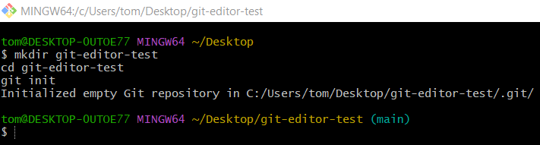

4️⃣ Create a Test File and Add File to Git
# Source: ScreenShots Source: Provided by: [Persons Table -> ID Column: 1, Name_En Column: Motasem Essam] -> Tool: [Lightshot Program] -> From [Operating System: Windows] on [3/6/2026]
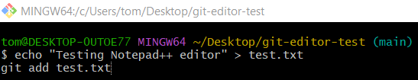
echo "Testing Notepad++ editor" > test.txt
git add test.txt
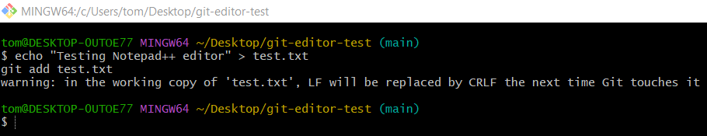

5️⃣ Trigger the Editor
# Source: ScreenShots Source: Provided by: [Persons Table -> ID Column: 1, Name_En Column: Motasem Essam] -> Tool: [Lightshot Program] -> From [Operating System: Windows] on [3/6/2026]
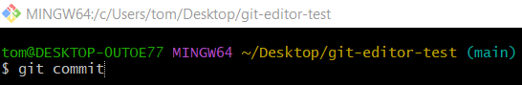
git commit
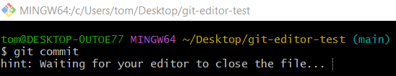
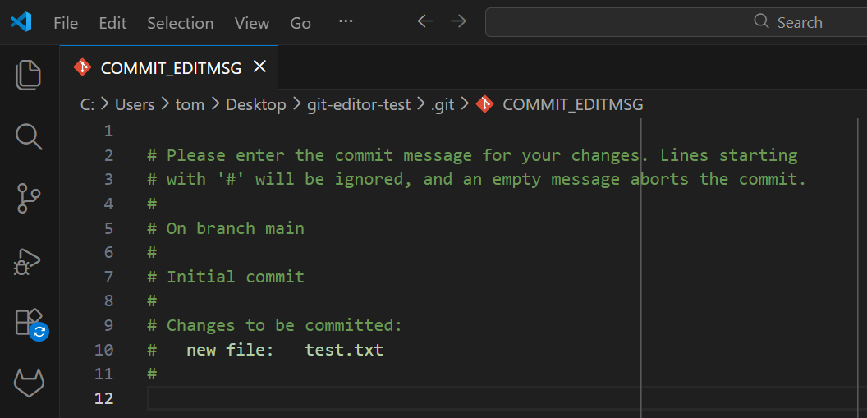

6️⃣ Write the Commit Message
# Source: ScreenShots Source: Provided by: [Persons Table -> ID Column: 1, Name_En Column: Motasem Essam] -> Tool: [Lightshot Program] -> From [Operating System: Windows] on [3/6/2026]
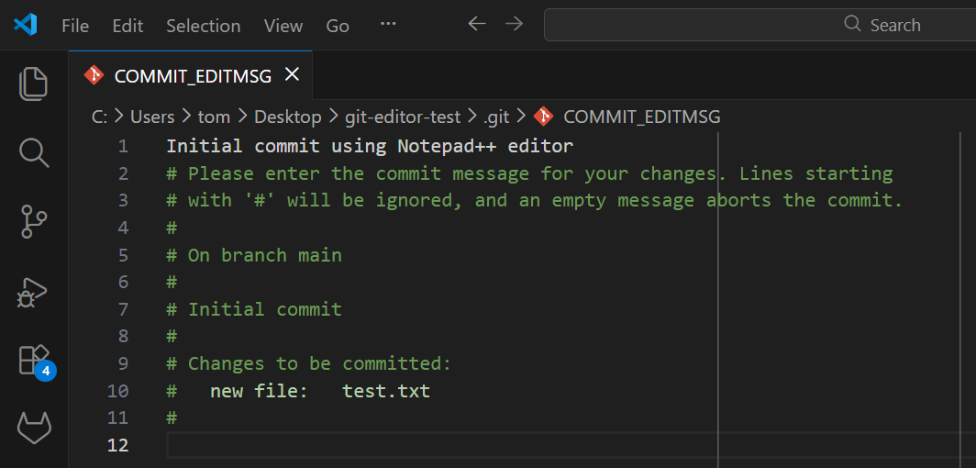
Initial commit using Notepad++ editor
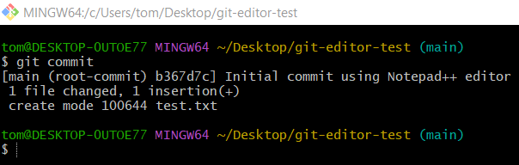

7️⃣ Verify the Commit
# Source: ScreenShots Source: Provided by: [Persons Table -> ID Column: 1, Name_En Column: Motasem Essam] -> Tool: [Lightshot Program] -> From [Operating System: Windows] on [3/6/2026]
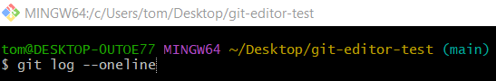
git log --oneline
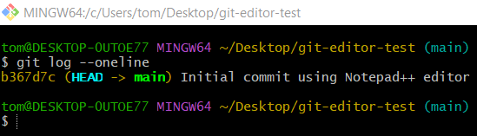

Enable colored output:

1️⃣ Create a Test Project Folder and Initialize a Git Repository
# Source: ScreenShots Source: Provided by: [Persons Table -> ID Column: 1, Name_En Column: Motasem Essam] -> Tool: [Lightshot Program] -> From [Operating System: Windows] on [3/6/2026]
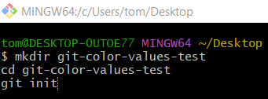
mkdir git-color-values-test
cd git-color-values-test
git init
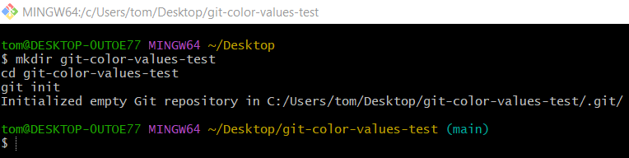

2️⃣ Create a Test File
# Source: ScreenShots Source: Provided by: [Persons Table -> ID Column: 1, Name_En Column: Motasem Essam] -> Tool: [Lightshot Program] -> From [Operating System: Windows] on [3/6/2026]
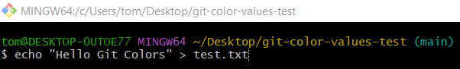
echo "Hello Git Colors" > test.txt
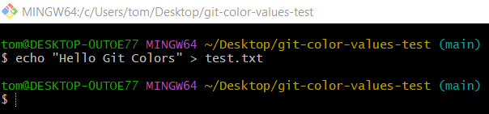
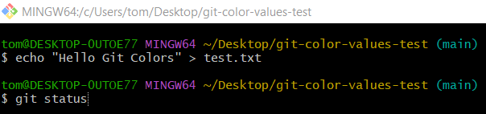
git status
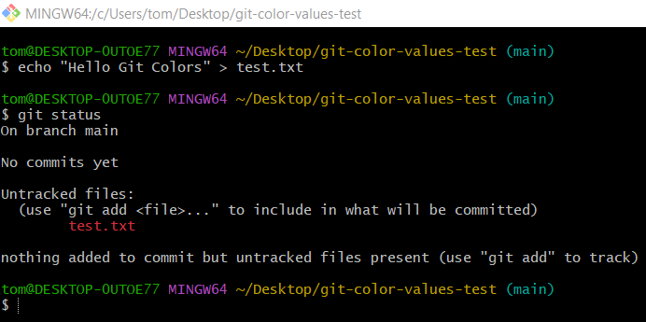

3️⃣ Enable colored output

Option 1: auto

Step 1: Set Value
# Source: ScreenShots Source: Provided by: [Persons Table -> ID Column: 1, Name_En Column: Motasem Essam] -> Tool: [Lightshot Program] -> From [Operating System: Windows] on [3/6/2026]
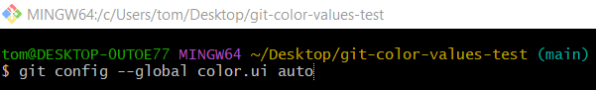
git config --global color.ui auto
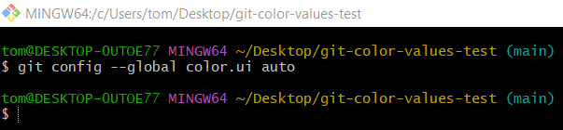

Step 2: Verify
# Source: ScreenShots Source: Provided by: [Persons Table -> ID Column: 1, Name_En Column: Motasem Essam] -> Tool: [Lightshot Program] -> From [Operating System: Windows] on [3/6/2026]
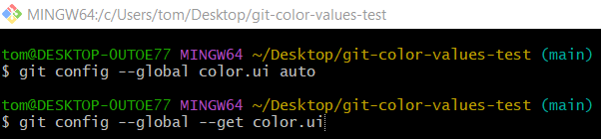
git config --global --get color.ui
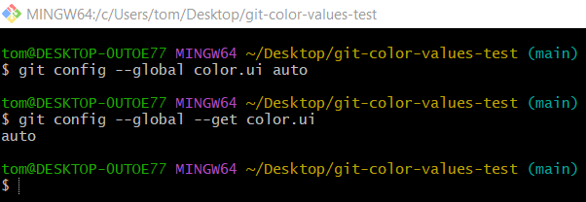

Step 3: Run a Git Command

Terminal
# Source: ScreenShots Source: Provided by: [Persons Table -> ID Column: 1, Name_En Column: Motasem Essam] -> Tool: [Lightshot Program] -> From [Operating System: Windows] on [3/6/2026]
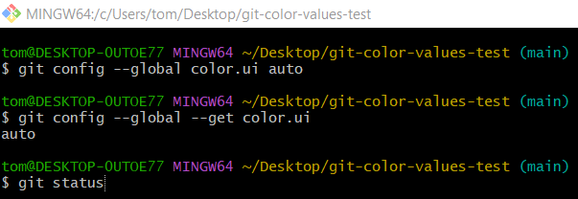
git status
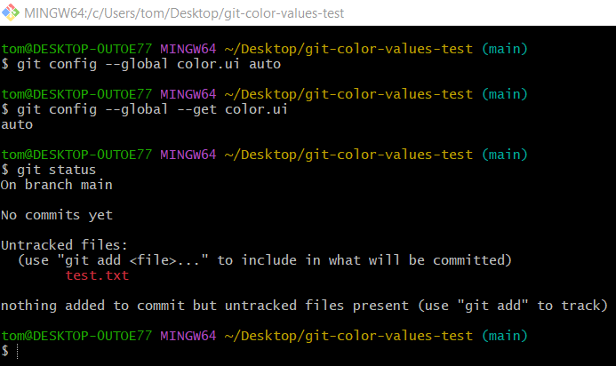

File
# Source: ScreenShots Source: Provided by: [Persons Table -> ID Column: 1, Name_En Column: Motasem Essam] -> Tool: [Lightshot Program] -> From [Operating System: Windows] on [3/6/2026]
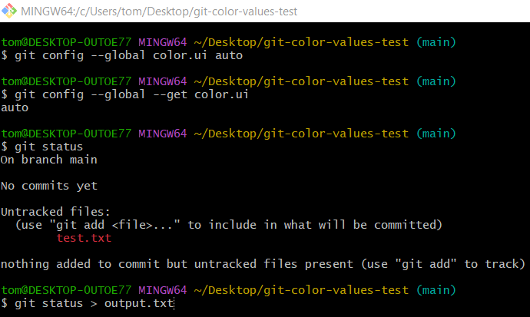
git status > output.txt
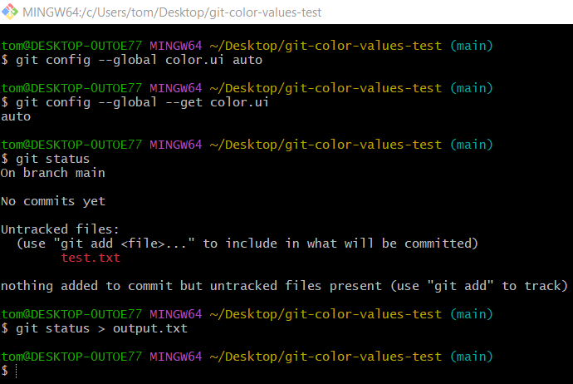
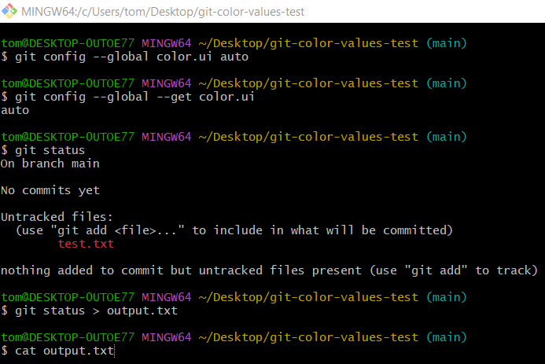
cat output.txt
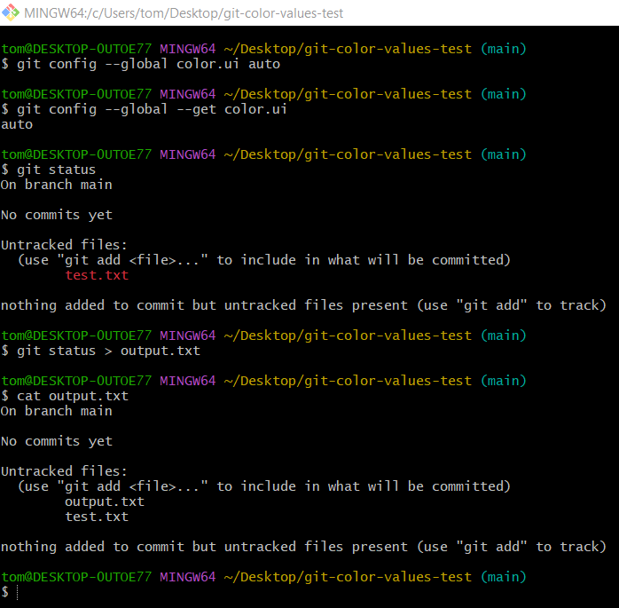

Option 2: always

Step 1: Set Value
# Source: ScreenShots Source: Provided by: [Persons Table -> ID Column: 1, Name_En Column: Motasem Essam] -> Tool: [Lightshot Program] -> From [Operating System: Windows] on [3/6/2026]
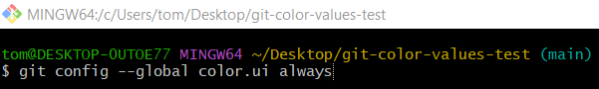
git config --global color.ui always
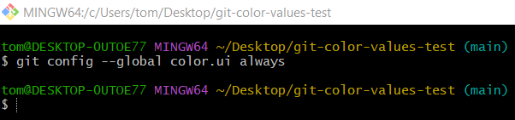

Step 2: Verify
# Source: ScreenShots Source: Provided by: [Persons Table -> ID Column: 1, Name_En Column: Motasem Essam] -> Tool: [Lightshot Program] -> From [Operating System: Windows] on [3/6/2026]
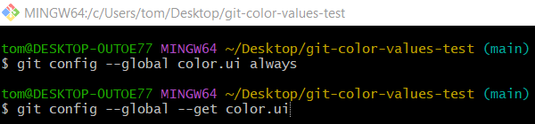
git config --global --get color.ui
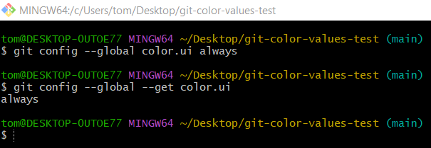

Step 3: Run a Git Command

Terminal
# Source: ScreenShots Source: Provided by: [Persons Table -> ID Column: 1, Name_En Column: Motasem Essam] -> Tool: [Lightshot Program] -> From [Operating System: Windows] on [3/6/2026]
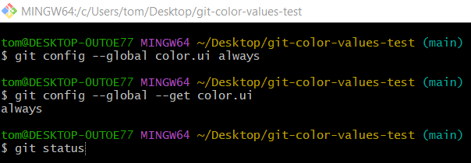
git status
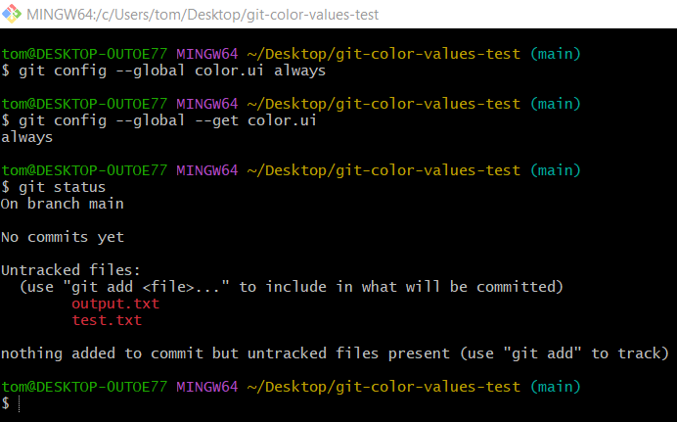

File
# Source: ScreenShots Source: Provided by: [Persons Table -> ID Column: 1, Name_En Column: Motasem Essam] -> Tool: [Lightshot Program] -> From [Operating System: Windows] on [3/6/2026]
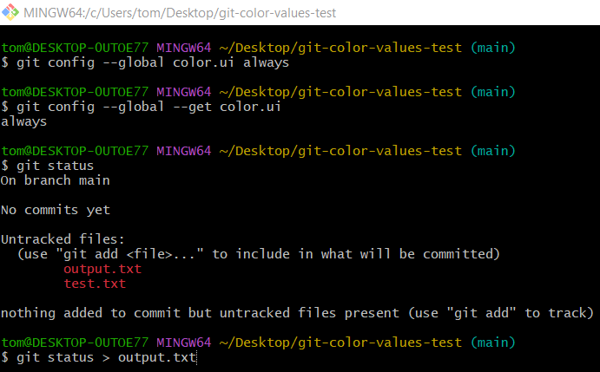
git status > output.txt
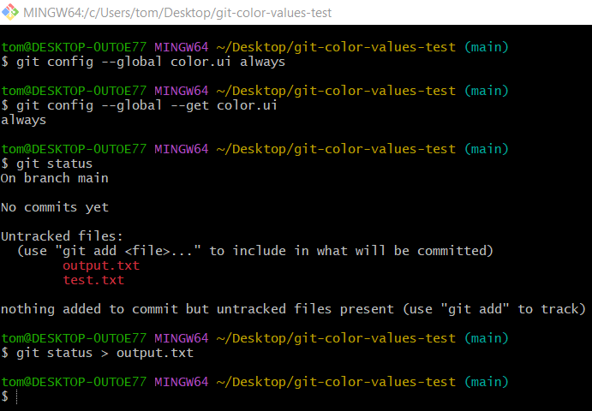
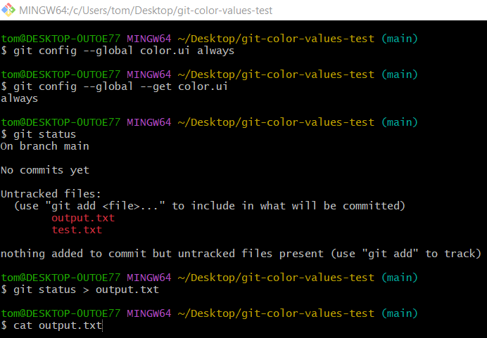
cat output.txt
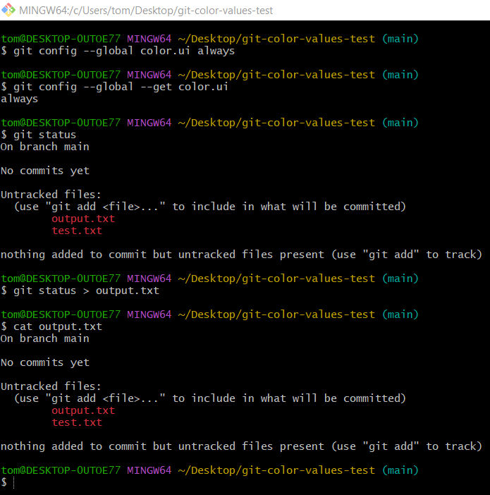

Option 3: never

Step 1: Set Value
# Source: ScreenShots Source: Provided by: [Persons Table -> ID Column: 1, Name_En Column: Motasem Essam] -> Tool: [Lightshot Program] -> From [Operating System: Windows] on [3/6/2026]
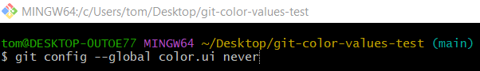
git config --global color.ui never
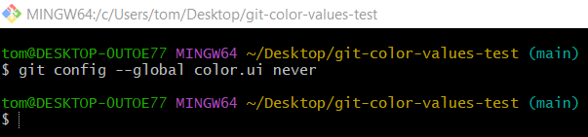

Step 2: Verify
# Source: ScreenShots Source: Provided by: [Persons Table -> ID Column: 1, Name_En Column: Motasem Essam] -> Tool: [Lightshot Program] -> From [Operating System: Windows] on [3/6/2026]
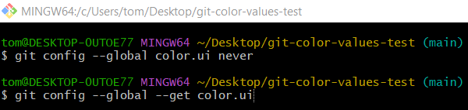
git config --global --get color.ui
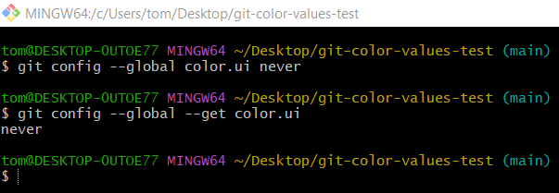

Step 3: Run a Git Command

Terminal
# Source: ScreenShots Source: Provided by: [Persons Table -> ID Column: 1, Name_En Column: Motasem Essam] -> Tool: [Lightshot Program] -> From [Operating System: Windows] on [3/6/2026]
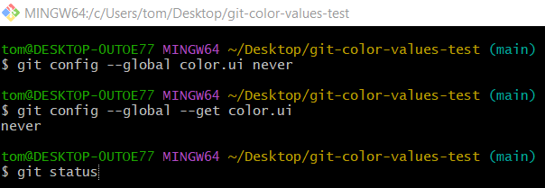
git status
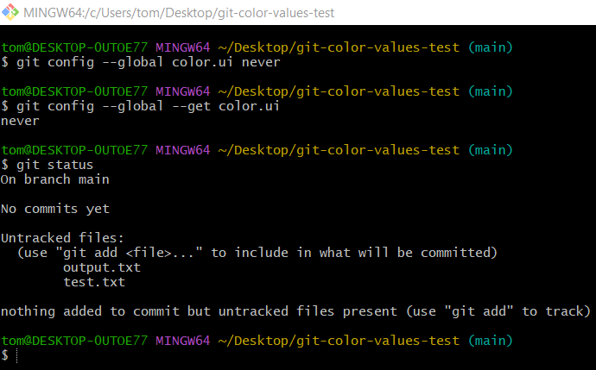

File
# Source: ScreenShots Source: Provided by: [Persons Table -> ID Column: 1, Name_En Column: Motasem Essam] -> Tool: [Lightshot Program] -> From [Operating System: Windows] on [3/6/2026]
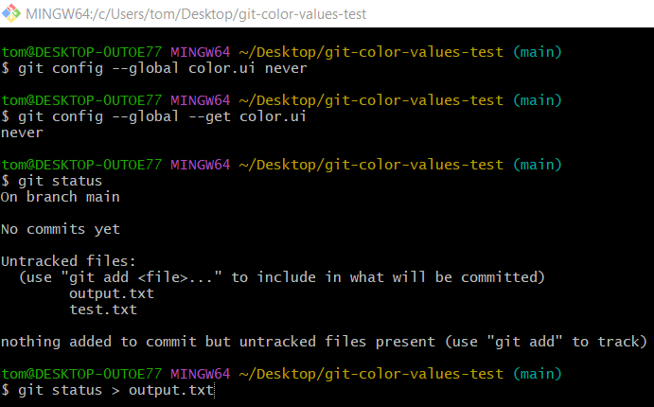
git status > output.txt

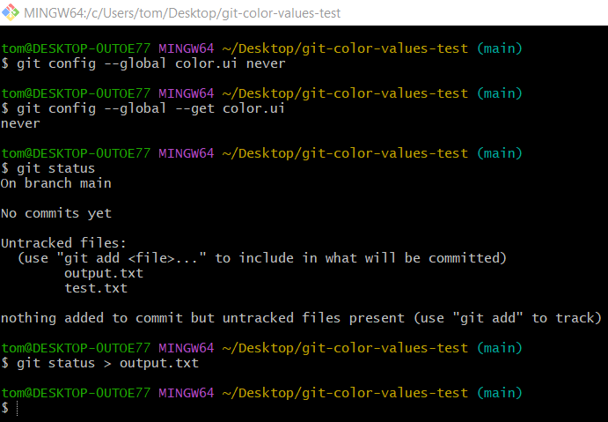
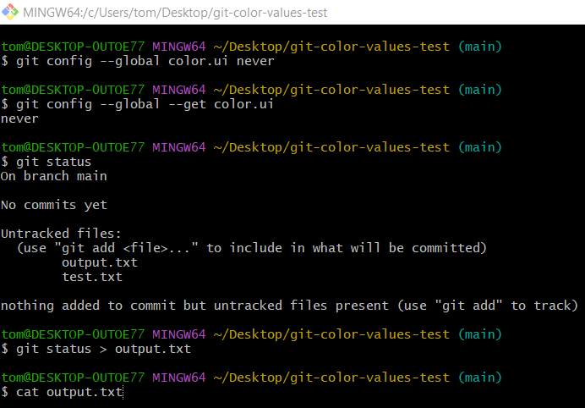
cat output.txt
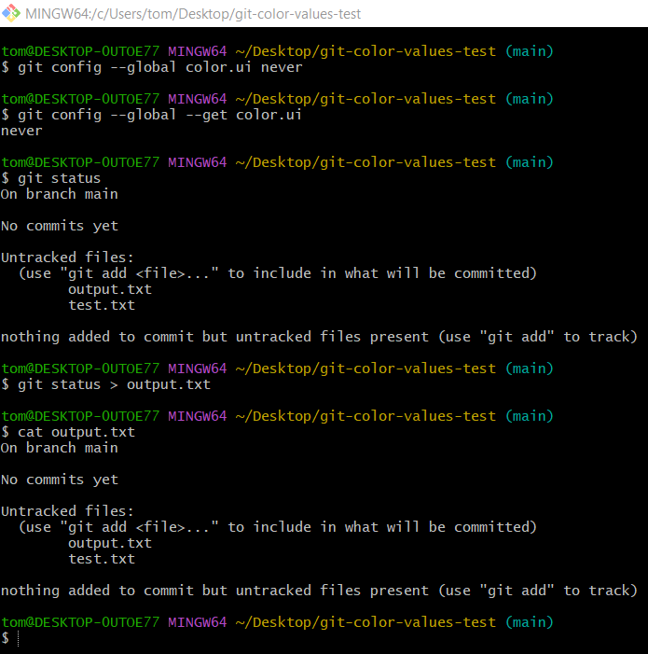

Opening the Configuration Editor
# Source: ScreenShots Source: Provided by: [Persons Table -> ID Column: 1, Name_En Column: Motasem Essam] -> Tool: [Lightshot Program] -> From [Operating System: Windows] on [3/6/2026]
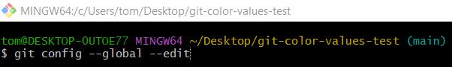
git config --global --edit
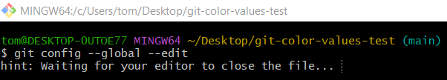
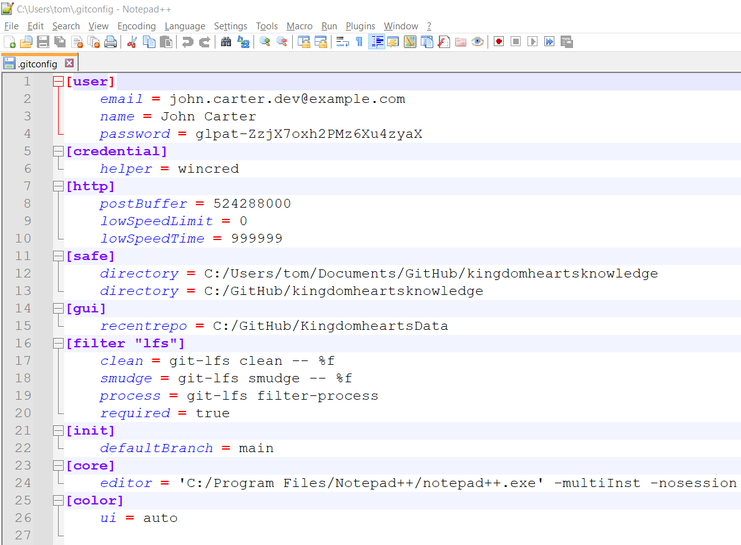
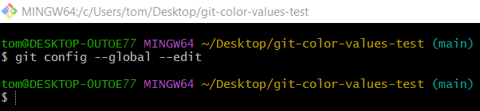

Access Git Config Help
# Source: ScreenShots Source: Provided by: [Persons Table -> ID Column: 1, Name_En Column: Motasem Essam] -> Tool: [Lightshot Program] -> From [Operating System: Windows] on [3/6/2026]
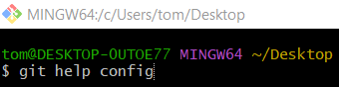
git help config
